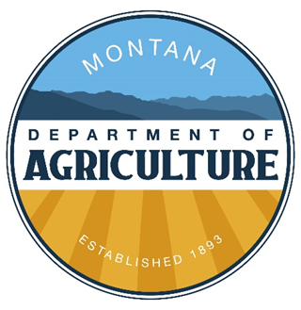
INITIAL PESTICIDE CERTIFICATION
NATIONAL CORE TRAINING COURSE AGENDA
April 12-14th, 2023 – Great Falls MT

Wednesday

8:00-8:30am Welcome

8:30-9:20 Chapter 1

9:20-10:00 Chapter 2

10:00-10:15 BREAK

10:15-11:00 Chapter 2 Exercise

11:00-12:30 Chapter 3

12:30-1:00pm LUNCH (provided)

1:00-2:15 Chapter 4

2:15-3:00 Chapter 5

3:00-3:15 BREAK

3:15-4:45 Chapter 6

4:45-5:00 Day 1 Review

5:00 Homework (Problems at the end of chapters)

Thursday

7:45-8:00am Running Review

8:00-9:20 Chapter 7

9:20-10:05 Chapter 8

10:05-10:15 BREAK

10:15-11:30 Chapter 9

11:30-12:15 Chapter 10

12:15-1:00pm LUNCH (provided)

1:00-1:45 Chapter 10 EXERCISE

1:45-2:30 Chapter 11 (Part 1)

2:30-2:45 BREAK

2:45-3:45 Chapter 11 Calculations and Calibration

3:45-4:15 Homework Review at the end of the chapters

4:15 Final Review/Questions/Evaluations

Friday

8:00-8:15am Exam Procedures

8:15-8:25 BREAK

8:25am-12:00pm TESTING (Core and Categories)

