**How to Create an ePass Account and Activate Your MTPlants Account**

**Step 1: Logon/Register**

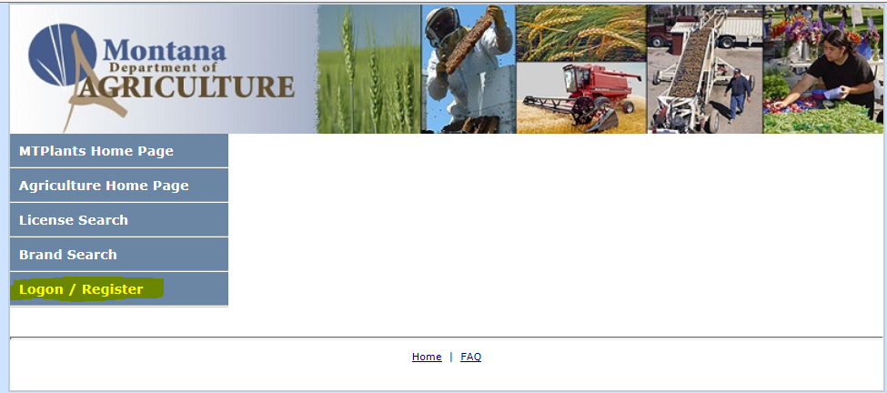

Go to: <https://mtplants.mt.gov>

Select Logon/Register.

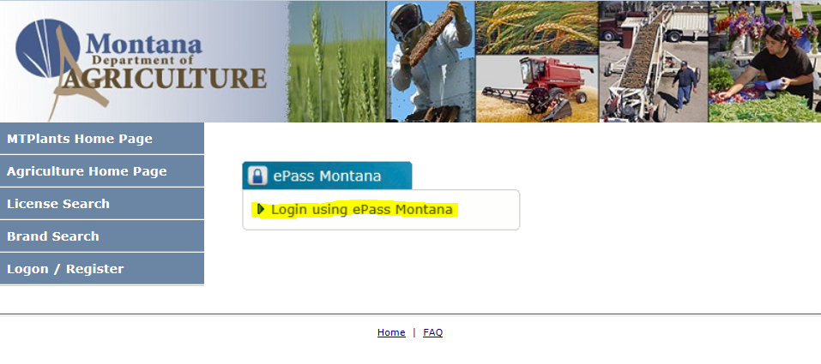

Select Login using ePass Montana.

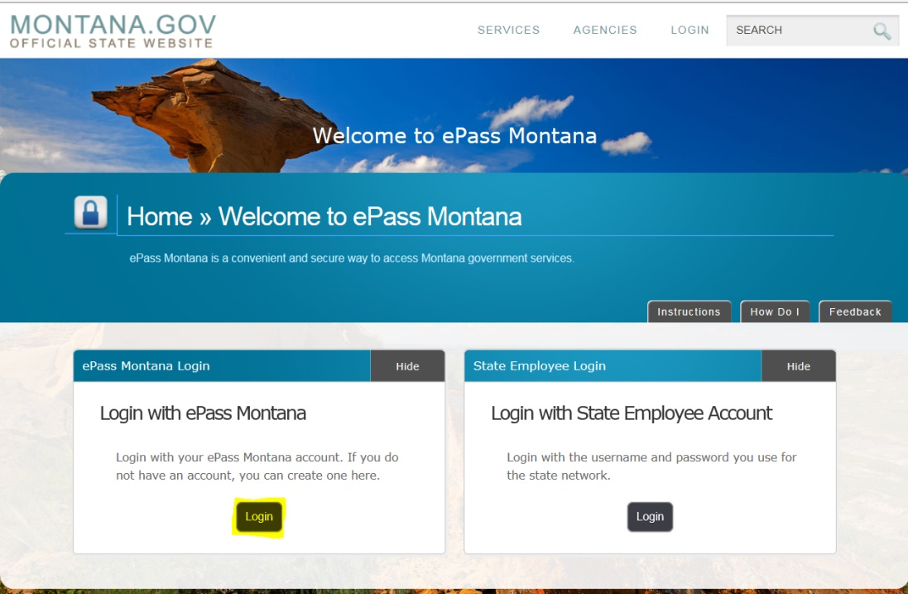

Select the Login button in the Login with ePass Montana box.

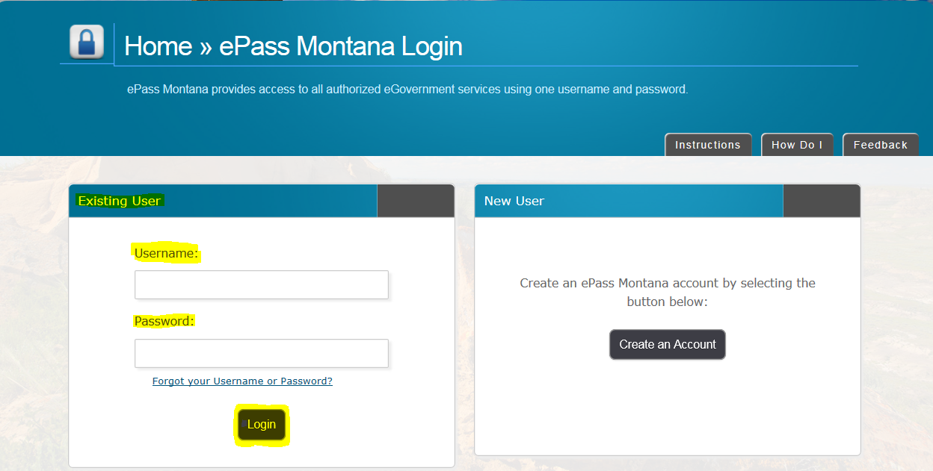

If you already have an ePass account enter your information in the Existing User box and select Login.

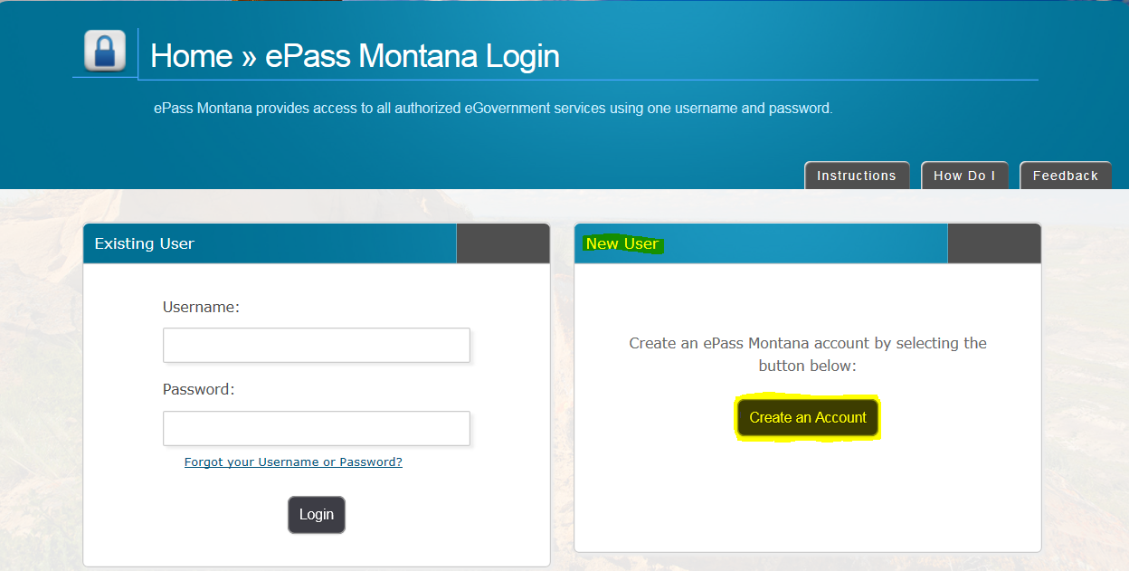

If you do not have an ePass account select the Create an Account button in the New User.

**Step 2: Account Creation**

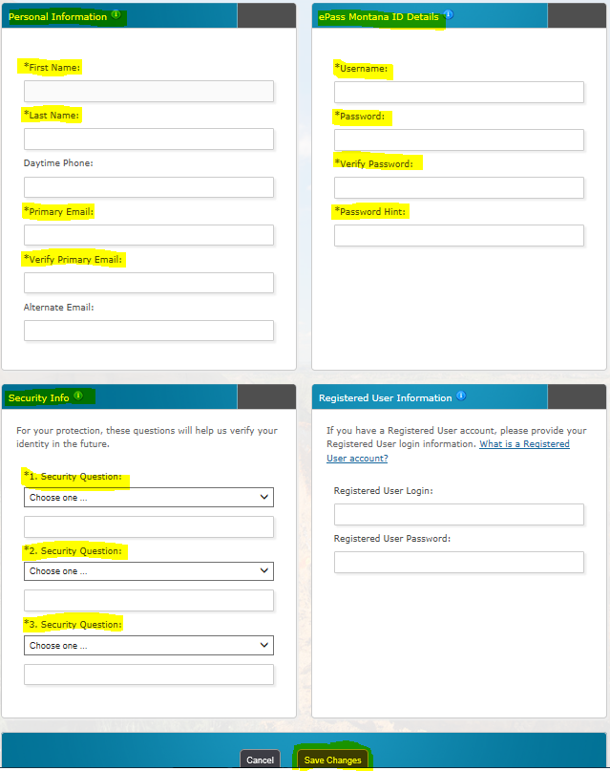

A screen with four sections will appear, three are for entering new user information and the fourth is another opportunity for existing users to login.

The highlighted yellow fields are required to set up an account.

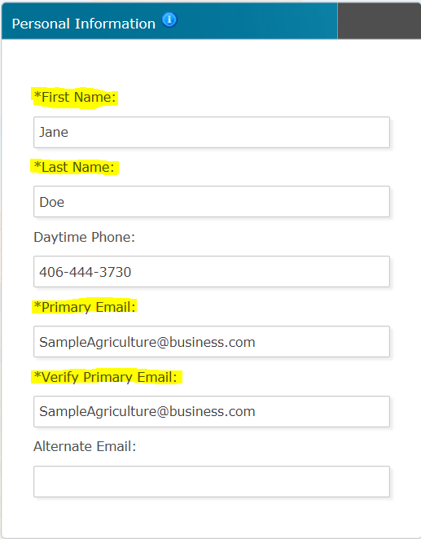

In the Personal Information section you are required to enter a First and Last Name and a Primary Email Address.

The Primary Email Address entered will receive the receipts for all transactions performed, all new product request confirmations, and all options to reset passwords and user names on ePass.

Due to the fact that employee responsiblilites change frequently, please use a company email address in this field.

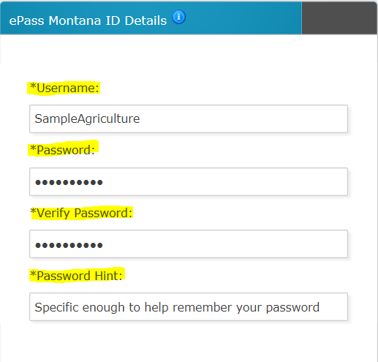

In the ePass Montana ID Details enter the Username, Password, and Password Hint fro the account.

Make this information Company specific rather than specific to an individaul employee.

The Username must be at least 6 characters long.

The password must be at least 8 characters long, use both letters and numbers, be different than your username, and is case sensitive.

Record your username and password in a secure location.

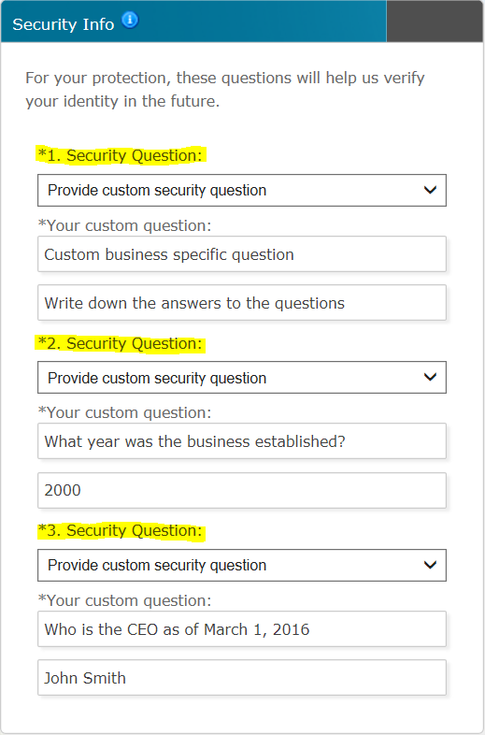

Security questions will allow you to retrieve a lost username or to reset your password.

You are required to enter 3 security questions.

It is suggested you use the Provide Custom Security Question option and enter company specific information.

This will prevent employees from having their private personal information linked to a business account.



Select the Save Changes button.

**Step 3: Linking your ePass account to your MTPlants account**

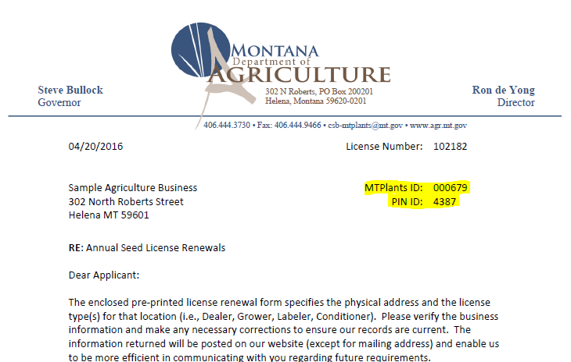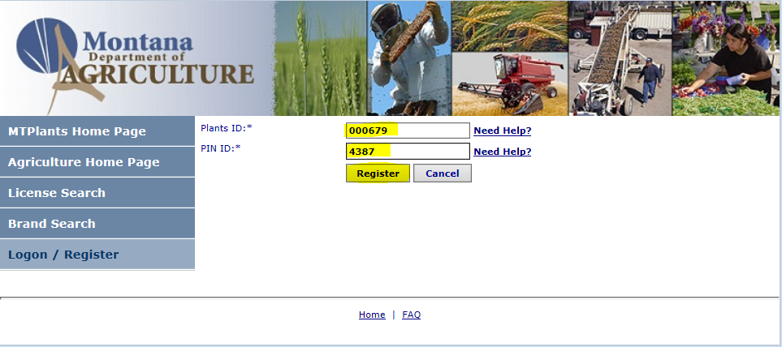

Locate the MTPlants ID and PIN ID listed on the Renewal Notice.

Enter the values into the Plants ID and PIN ID field.

Select Register.

**Step 4: Finish**

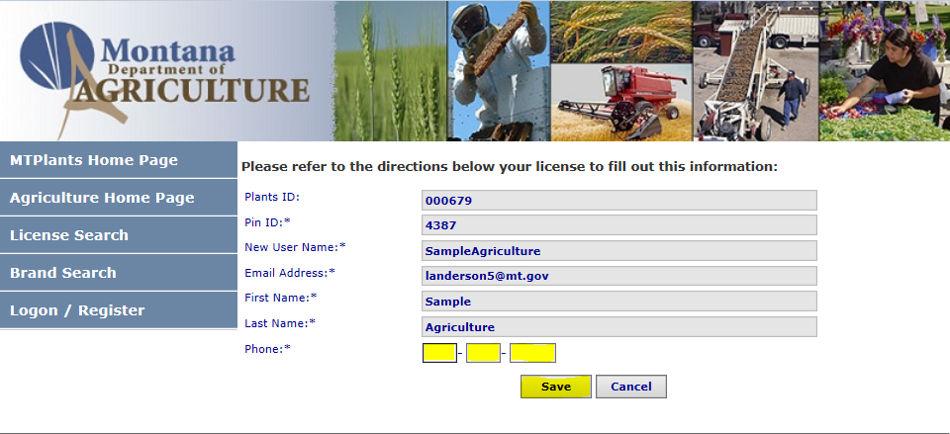

Enter the phone number for the business.

Select Save.

This brings up the Account Home page for the company. From here you can renew license(s), renew products, register new products, enter tonnage/assessments, view payment and contact information, and print licenses.