**How to Renew a Feed License and Products Online with MTPlants**

The new database system MTPlants allows users to renew their license and products online as well as add new products for the upcoming year. The new products and their corresponding labels are automatically sent to the Feed Specialist for review and approval. You will be notified immediately upon approval and will be able to print an updated Brands Certificate that will contain all of your current brands. If there are no new products added, a Brand Certificate can be printed immediately following the renewal process.

**Step 1: Log In**

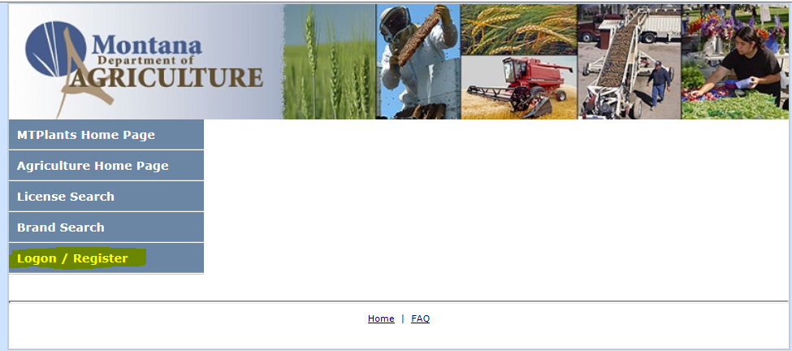

Go to: <https://mtplants.mt.gov>

Select Logon/Register.

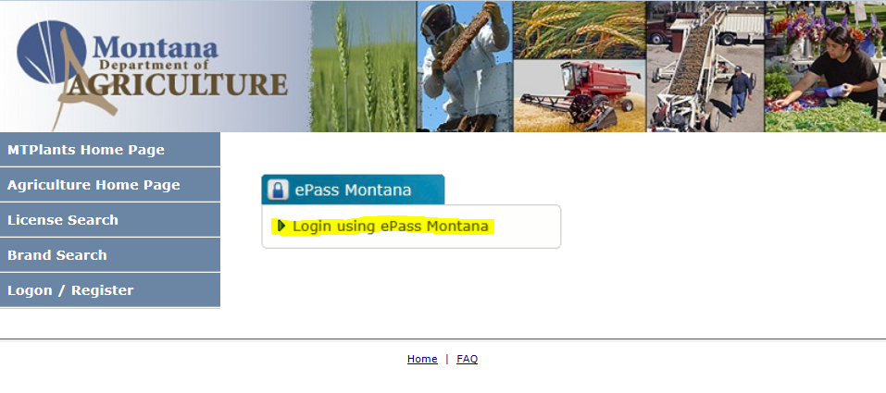

Select Login using ePass Montana.

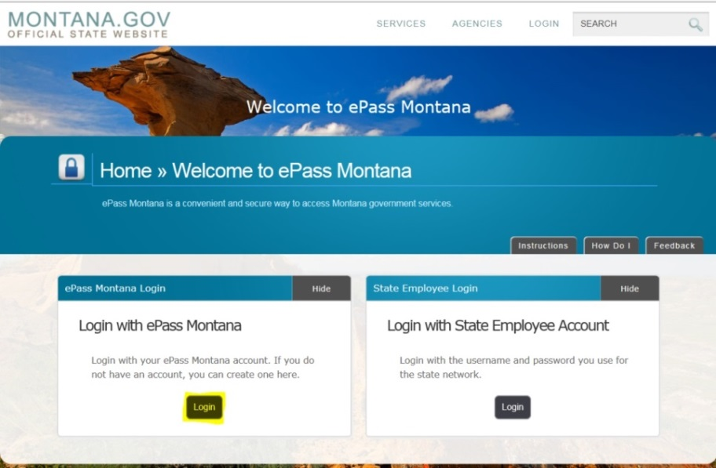

Select the Login button in the Login with ePass Montana box.

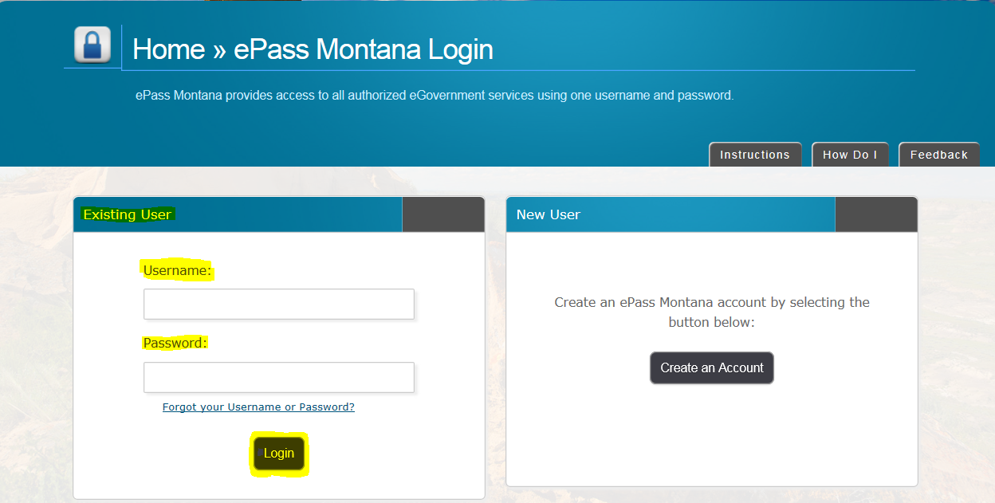

If you already have an ePass account enter your information in the Existing User box and select Login.

If you do not have an account please see: How to Create and ePass Account and Activate Your MTPlants Account.

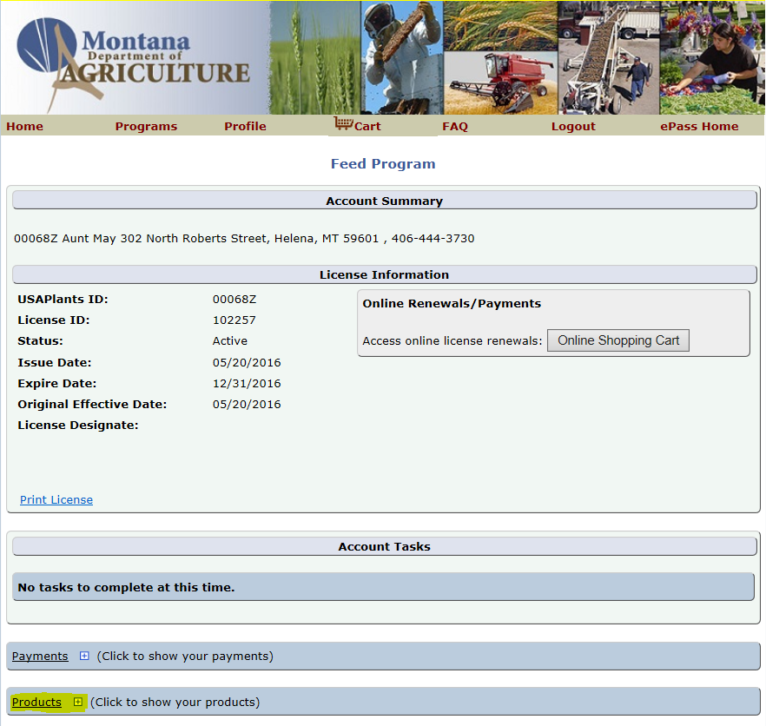

If your company has multiple program licenses this brings you to the Account Home page.

Select the hyperlink for the program you want to renew products for.

If you have a single program license this brings you to the Program Home page.

**Step 2: Adding New Products** This step must be done first before renewing your license or the rest of your brands. If your company has no new products skip to step 3.

Scroll down and expand the Products grid.

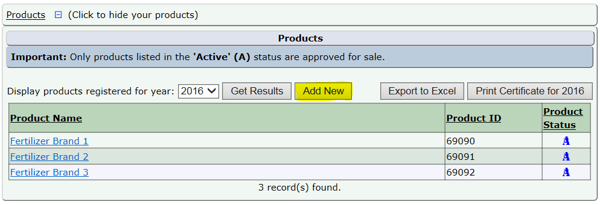

This displays all the products for your company.

Select the Add New button.

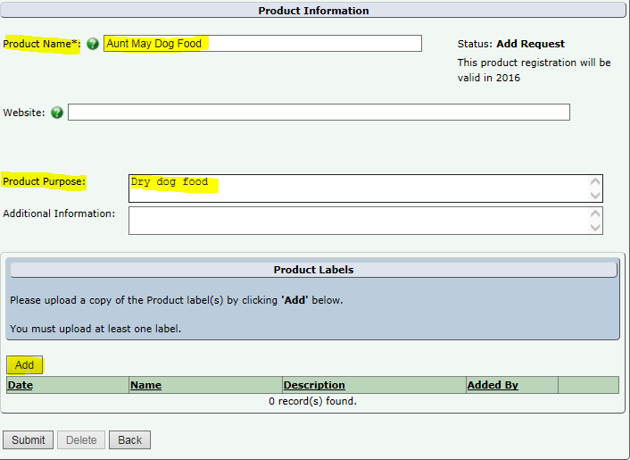

Enter the name of the Product exactly as it appears on the label.

If you would like, you can enter a product description.

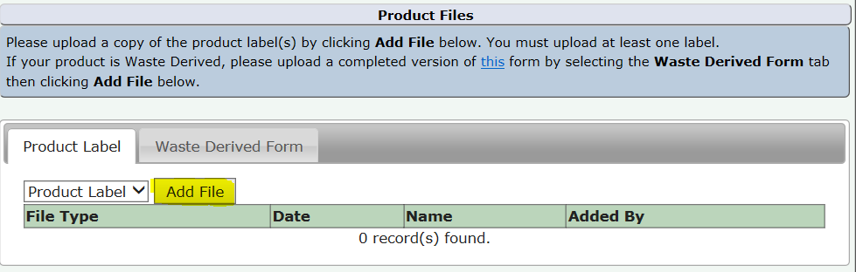

On the Product Label tab, Select the Add File button to upload the products label.

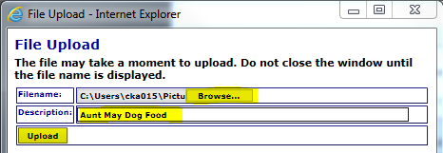

This File Uploader will appear (your pop-up blocker must be off for this to function).

Enter a description of the label, this is typically the product name followed by the year.

Select Upload.

The label will appear under the Product Files grid.

Select Submit.

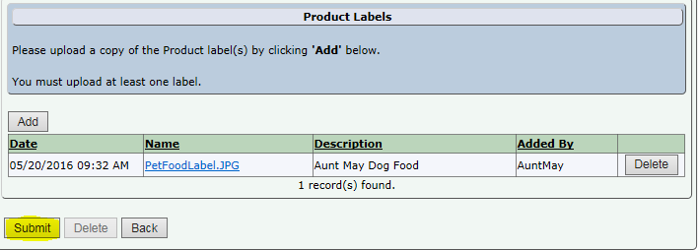

If you need to add another product Select Add Another Product.

If you are finished adding new products, Select Close. You will be returned to the Program Home Page.

Repeat the process beginning with selecting the Add button in the Products grid.

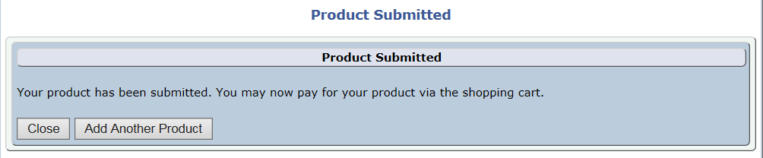

**Step 3: Add License and Products to the Shopping Cart**

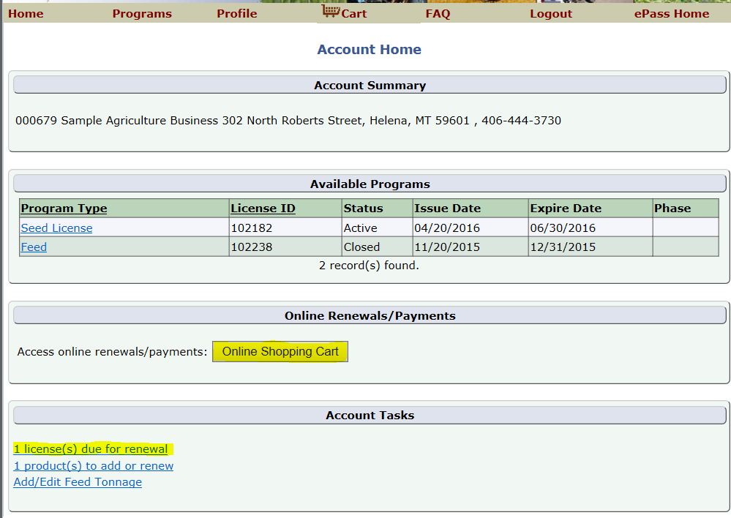

From the Account Summary on the Account Home page select either the Online Shopping Cart button or the License Due for Renewal hyperlink in the Account Tasks.

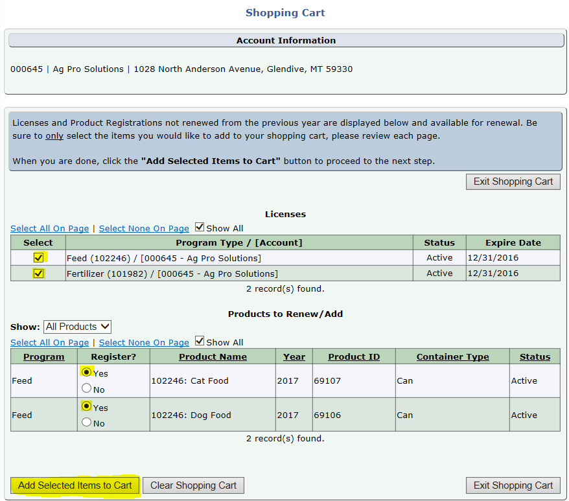

This will bring you to the Shopping Cart.

Select the check box next to the license(s) you would like to renew.

Select the Yes radial for all the products you wish to register.

Then select Add Selected Items to Cart

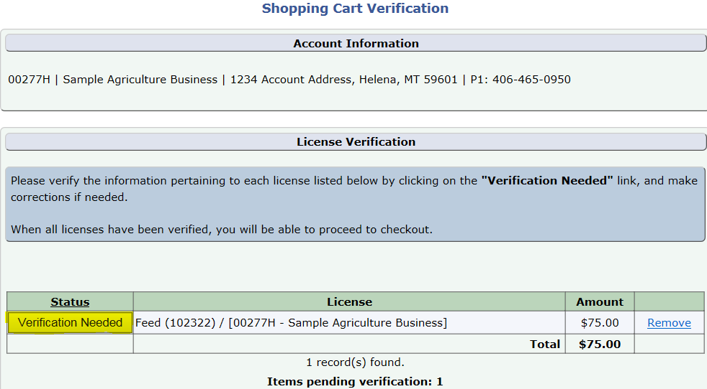

Select the Verification Needed button.

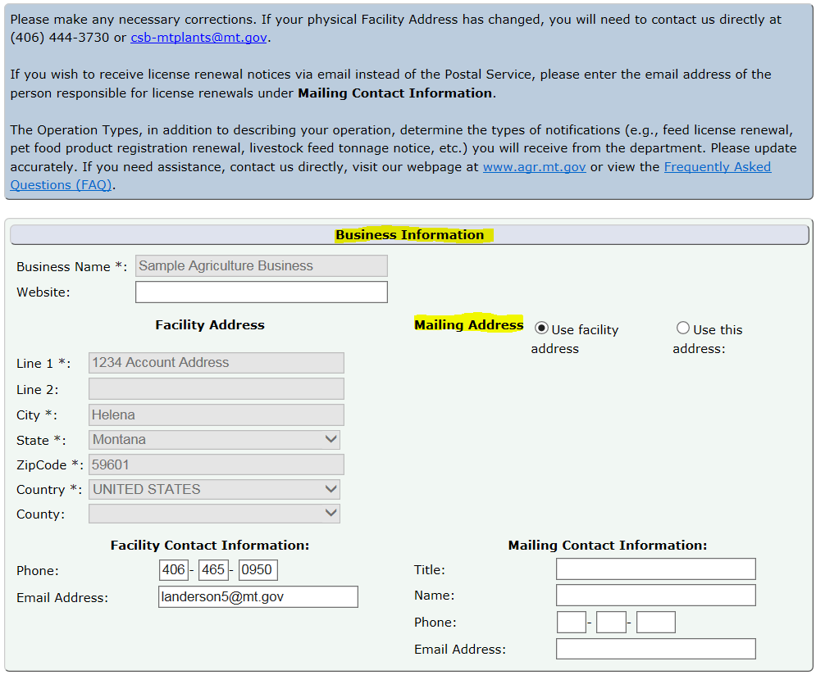

Verify your Business Information.

If you need to change the physical Facility Address, you will need to contact us directly at (406) 444-3730 or [csb-mtplants@mt.gov](mailto:csb-mtplants@mt.gov).

If the Mailing address differs from the Facility Address select the “Use this address” radial and enter the appropriate mailing address.

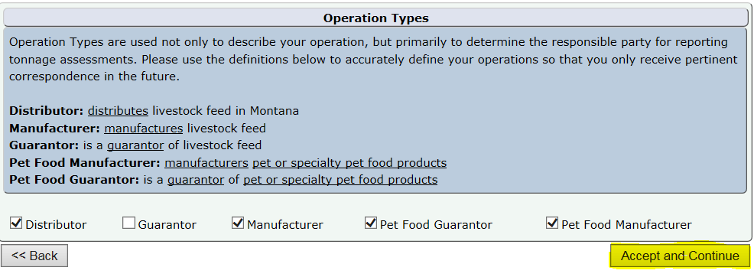

Verify the Operation Type(s) listed for this company and make any necessary changes.

Select Accept and Continue.

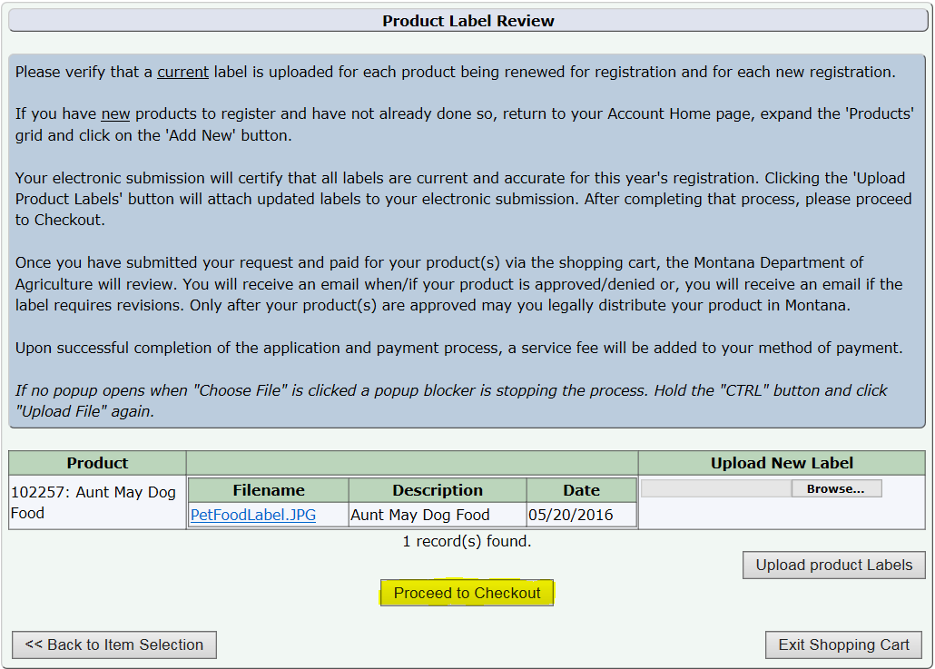

This brings up the Product Review Page.

If all the labels appear correct select Proceed to Checkout.

If you need to change a label Select Browse in the Upload New Label column next to the product.

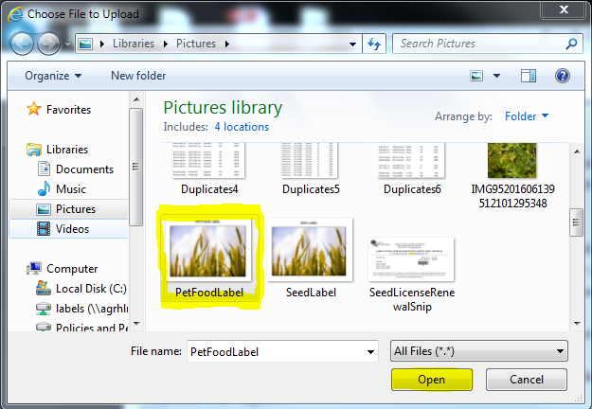

Browse to the location the label is stored and Select the new label.

Select Open.

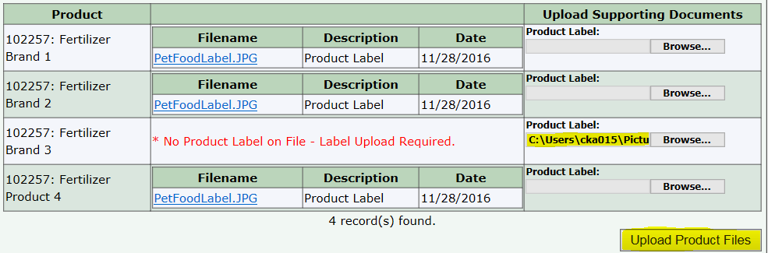

The file path will appear next to the product. When all of the new labels have been uploaded Select Upload Product Files.

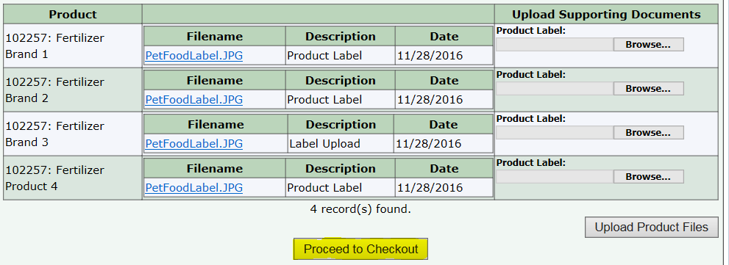

Select Proceed to Checkout

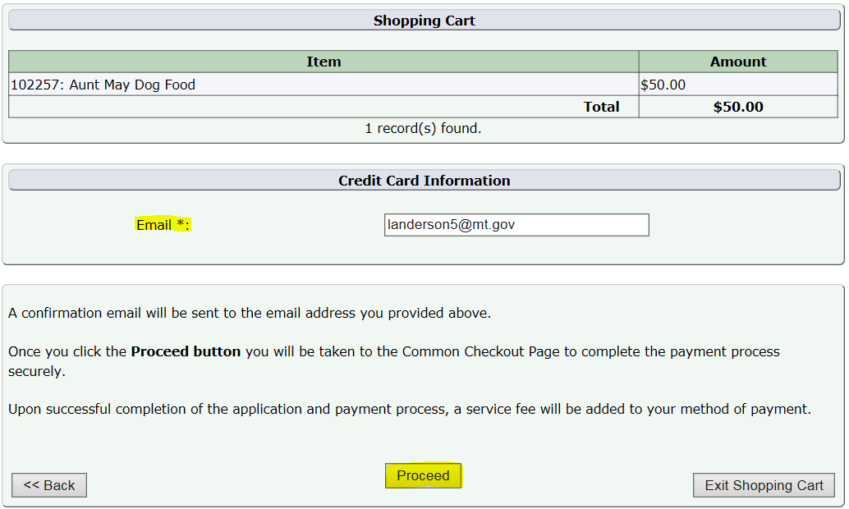

Verify the amount and email address (this will be the email that receives the receipt and product approval/denial emails).

Select Proceed.

**Step 4: Payment Information & Method**

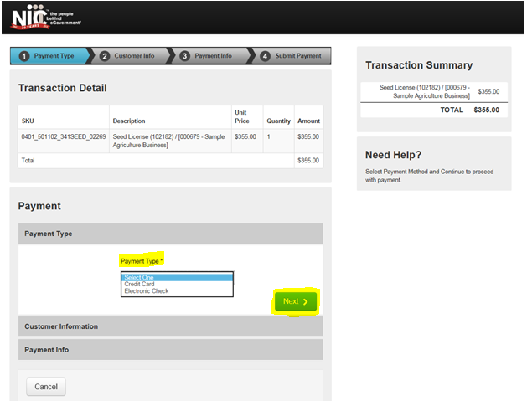

This transfers you over to the NIC payment site.

Select the Payment Type you would like to use from the dropdown.

Select Next.

Note: The processing fees vary based on the payment type: E-Checks are charged a flat $2 fee, and Credit Cards are $1.25 + 1.995% of the transaction amount.

**Credit Card**

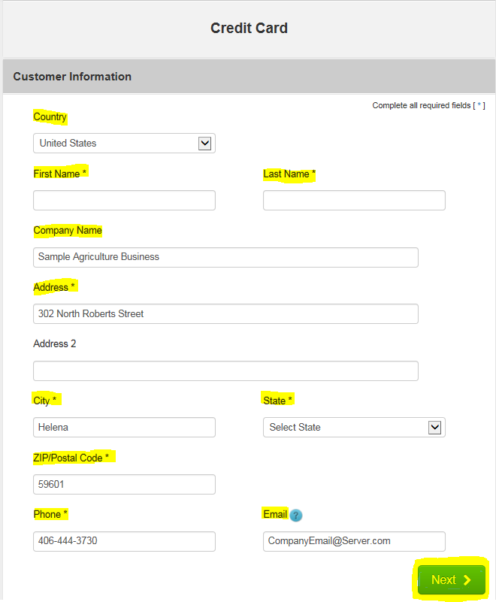

Fill out the Customer Information section including: Country, First and Last Name, Company Name, Address, City, State, ZIP Code, Phone Number, and Email.

Select Next.

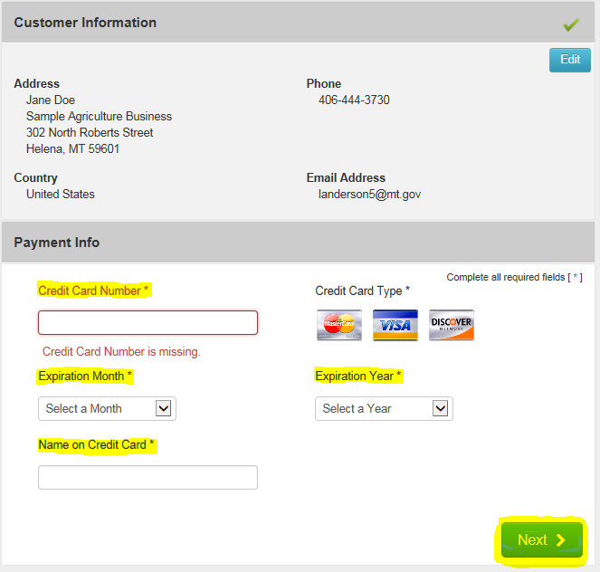

Verify the Customer Information and enter the Payment Information including the Credit Card Number, Expiration Month, Expiration Year, and Name on Credit Card.

Select Next.

Note: The Montana Department of Agriculture does not accept American Express.

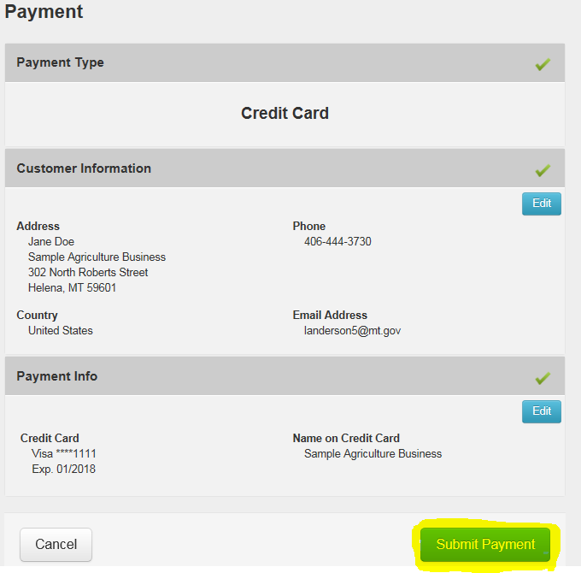

Verify the Customer Information and the Payment Info.

Select Submit Payment.

This will send you to the payment confirmation page and give you an opportunity to print your license. (See Step 9)

**Electronic Check (E-Check)**

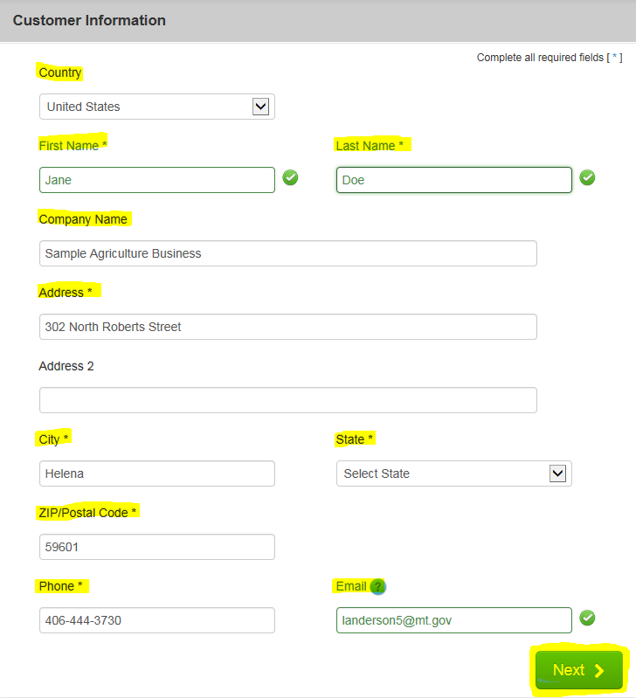

Fill out the Customer Information section including: Country, First and Last Name, Company Name, Address, City, State, ZIP Code, Phone Number, and Email.

Select Next.

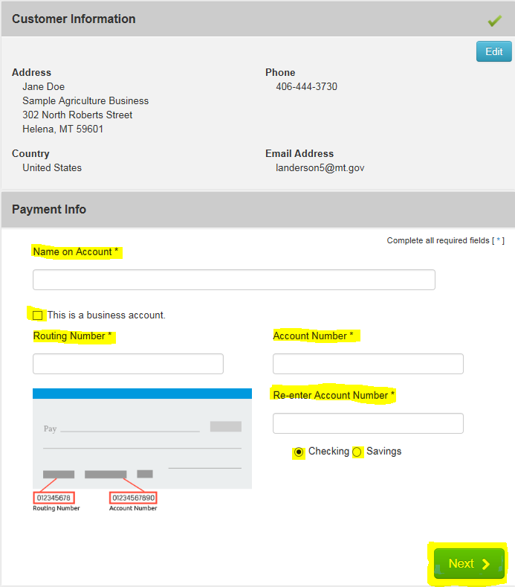

Verify the Customer Information and enter the Payment Information including the Name on the Account, Routing Number, Account Number, Re-enter the Account Number, and select the appropriate account type (checking or savings).

If this is a Business Account, select the “This is a business account” check box.

Select Next.

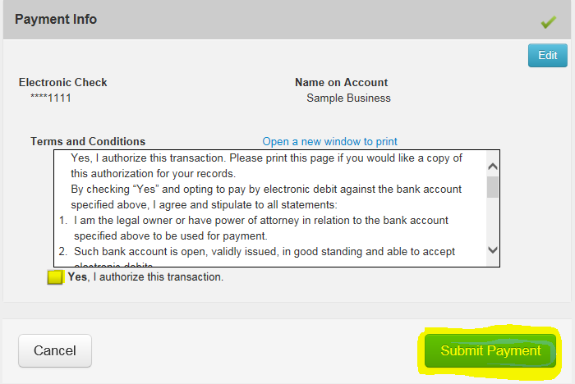

Read through to the bottom of the Terms and Conditions.

Select the check box to authorize the transaction.

Select the Submit Payment button.

This will send you to the payment confirmation page and give you an opportunity to print your license.

**Step 5: Payment Confirmation**

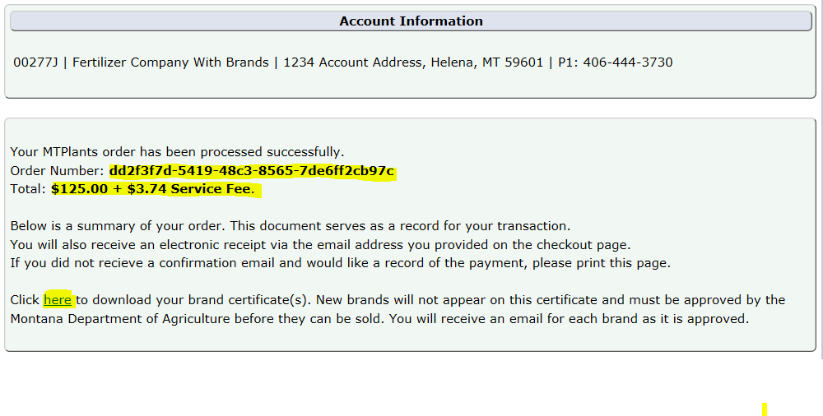

You will be transferred to the payment confirmation page and a confirmation email will be sent to the email address provided during checkout.

On this page you will be able to see the transaction order number and the total of the transaction.

Select the blue “here” hyperlink to download the brand certificate.

Now that the payment has been processed you will need to print your new license by selecting the Print hyper link.

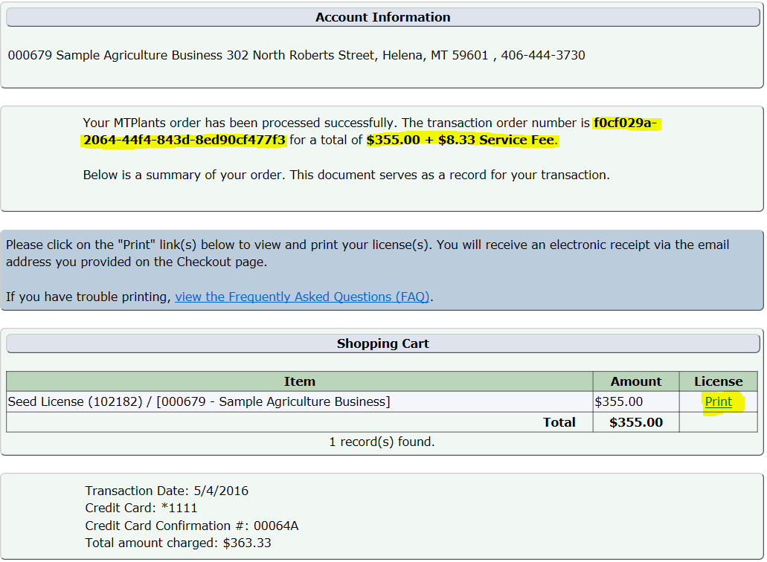

**Step 6: Print an Updated Product Certificate**

The Montana Department of Agriculture will review your product label and contact you via email if your product is approved, denied, or if there are further questions.

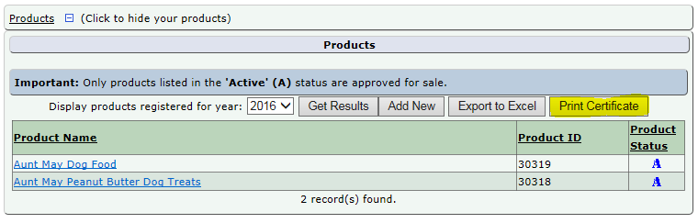

If the product is approved you will then be able to log into your MTPlants account and print an updated product certificate.