**How to Add Fertilizer Quarterly Tonnage**

**Step 1: Log In**

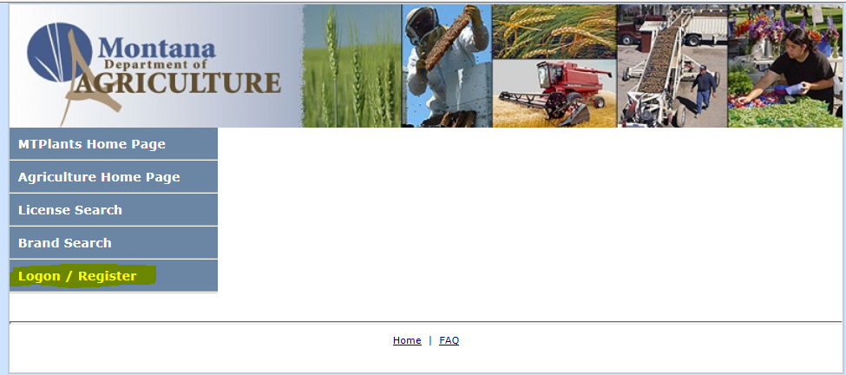

Go to: <https://mtplants.mt.gov>

Select Logon/Register.

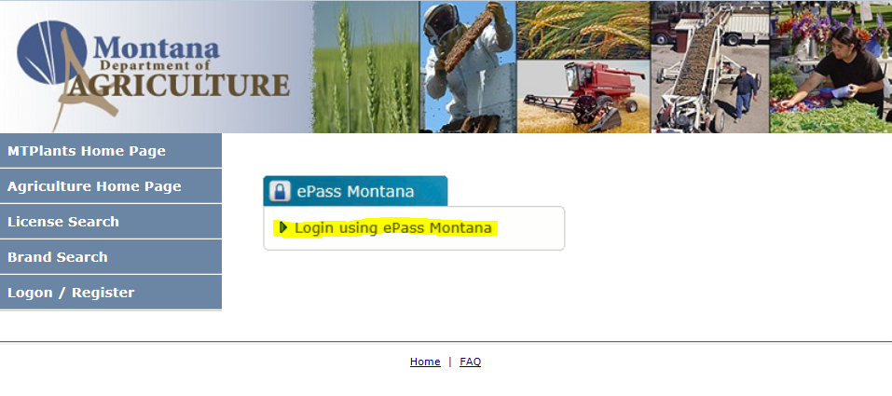

Select Login using ePass Montana.

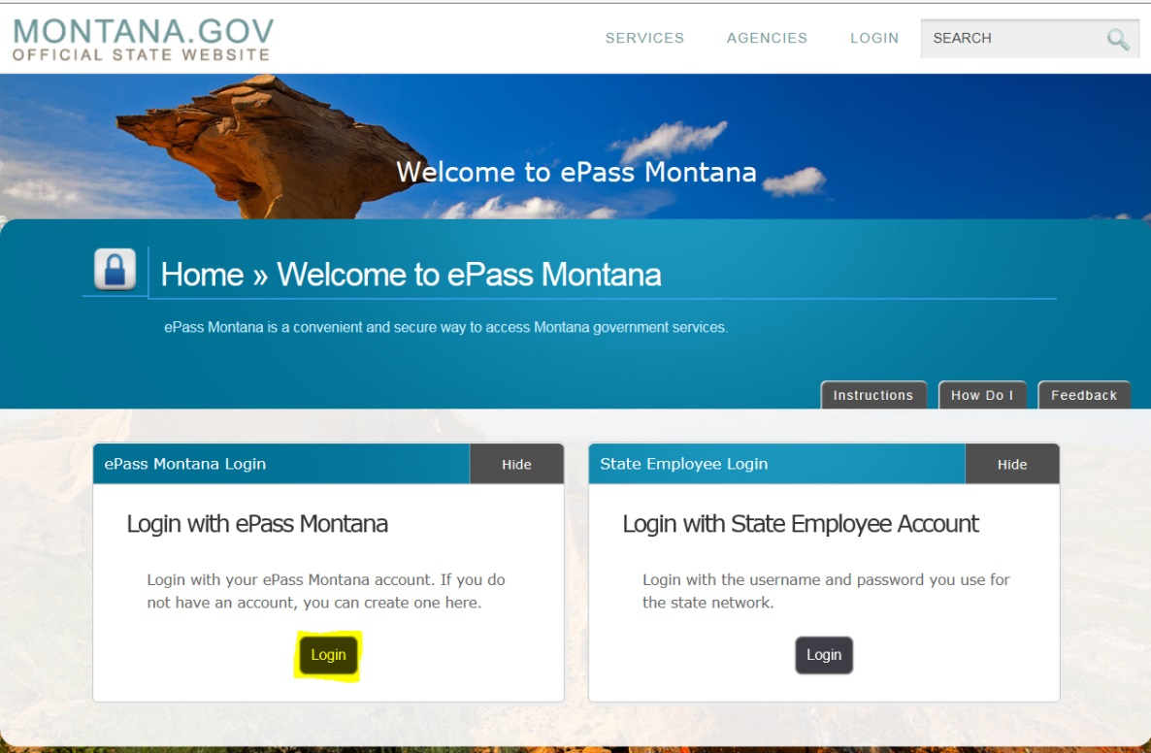

Select the Login button in the Login with ePass Montana box.

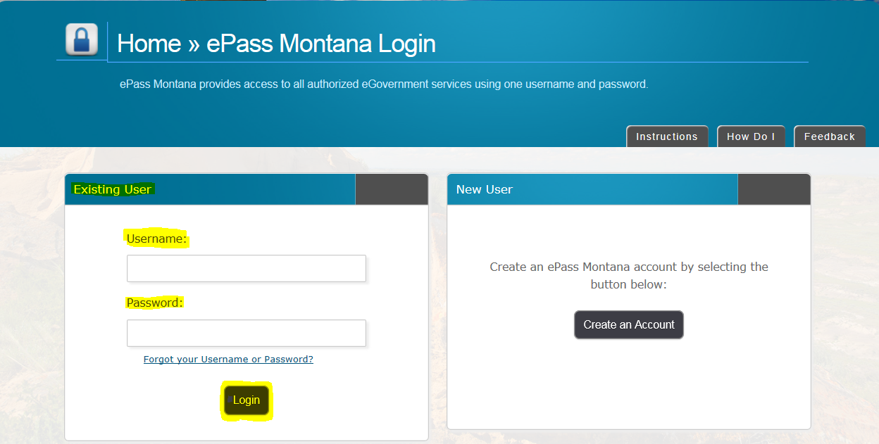

If you already have an ePass account enter your information in the Existing User box and select Login.

If you do not have an account please see: How to Create and ePass Account and Activate Your MTPlants Account.

**Step 2: Entering Tonnage Information**

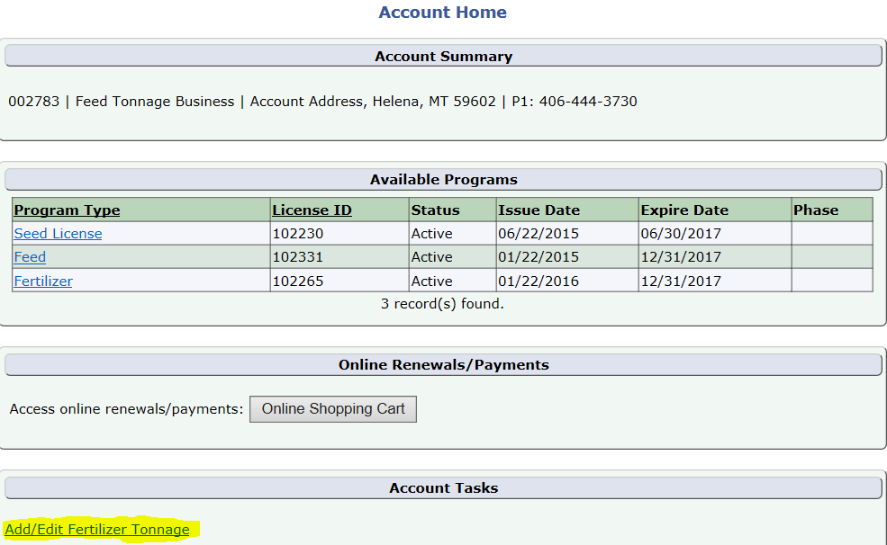

From the Account Summary on the Account Home page select the Add/Edit Fertilizer Tonnage hyperlink in the Account Tasks.

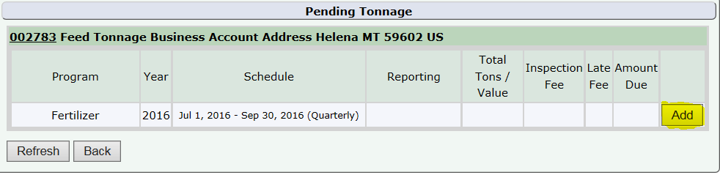

This brings up the Tonnage Grid. Select the Add button next to the tonnage you would like to enter.

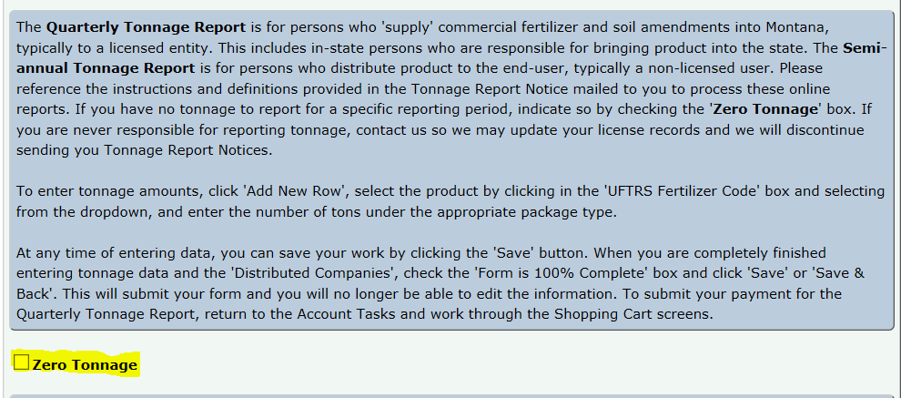

The Tonnage Edit screen will then appear. If you have no tonnage to report for the period indicated Select the Zero Tonnage box.

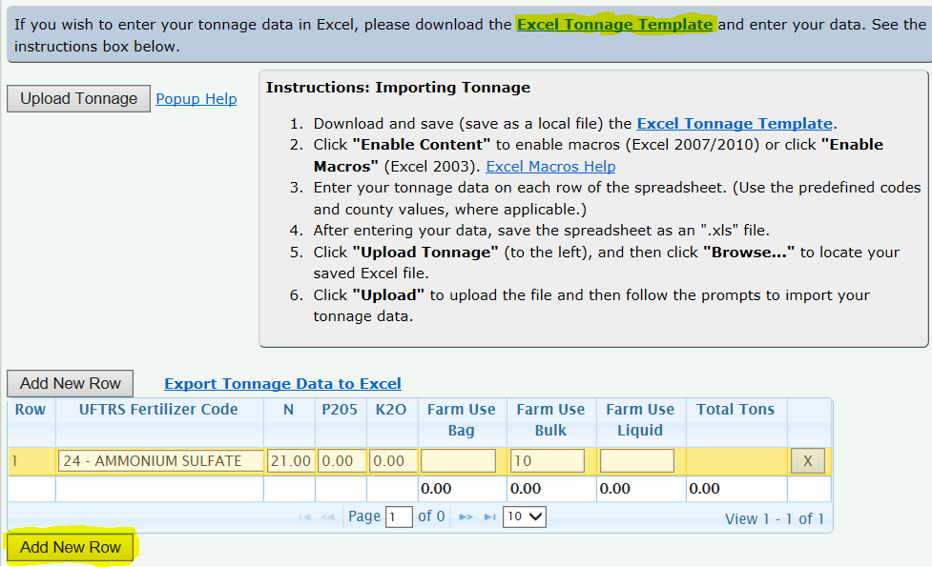

You then must list all the companies and their physical location you distributed product to in Montana.

Enter the Company name and city in the corresponding fields and Select Add

There are two ways to add tonnage. You can follow the instructions to import your tonnage information using a downloaded spread sheet. Or you can manually add the data by selecting Add New Row, Selecting the tonnage type from the drop down and entering in the amount.

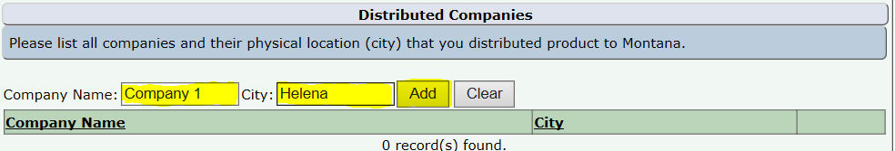

When you are ready to submit your report, Select the Form is 100% Complete box and then Select Save & Back.



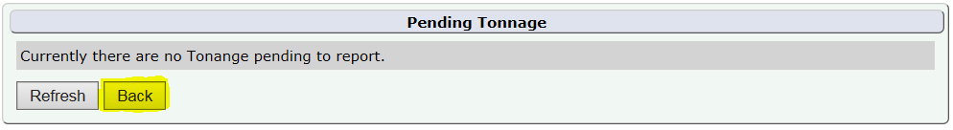

If you have no other tonnage due to report Select the Back button.

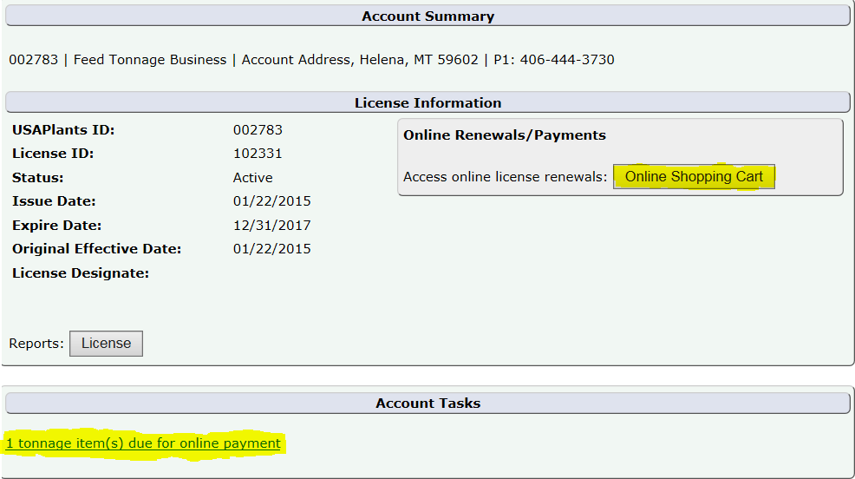

You are then returned to the Program page, Select either the Online Shopping Cart button or the blue tonnage hyperlink in the Account Tasks.

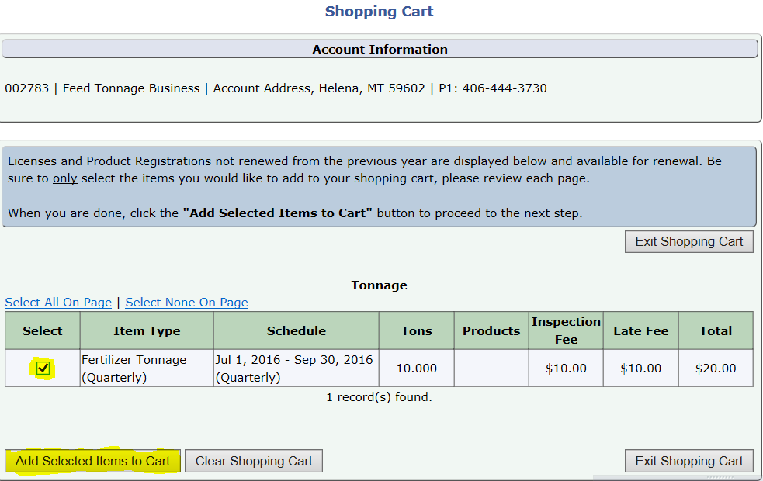

Check the box next to the Fertilizer Tonnage you wish to pay for and Select the Add Selected Items to Cart button.

**Step 3: Verification of Cart Total**

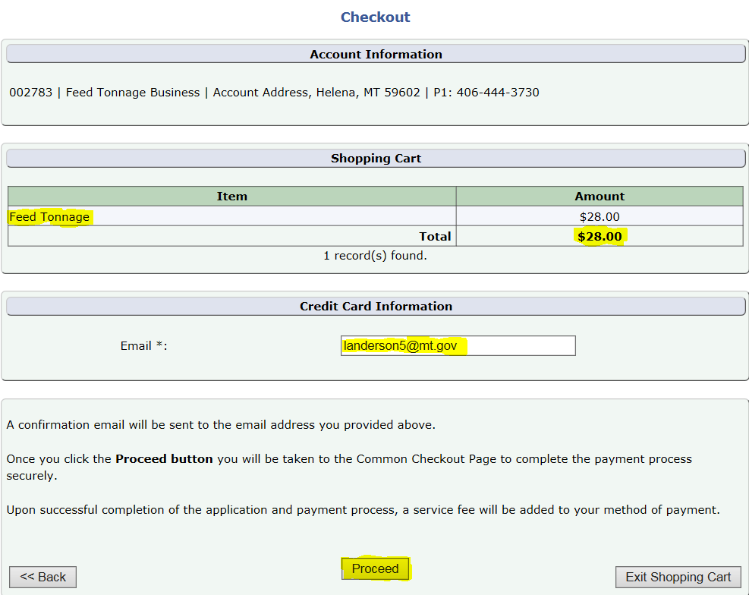

Verify the Total Amount and the email address.

This will be the email address that receives the payment confirmation email.

When the information looks correct select Proceed.

**Step 4: Payment Information & Method**

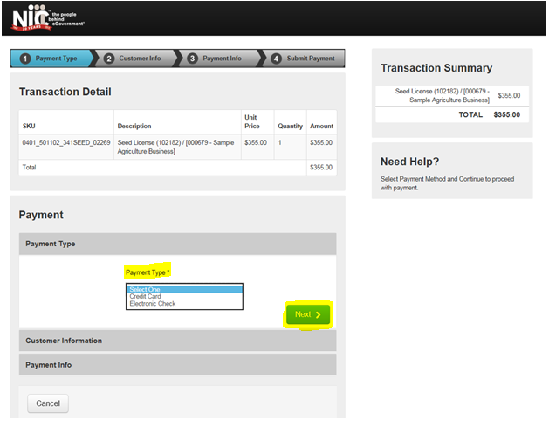

This transfers you over to the NIC payment site.

Select the Payment Type you would like to use from the dropdown.

Select Next.

Note: The processing fees vary based on the payment type: E-Checks are charged a flat $2 fee, and Credit Cards are $1.25 + 1.995% of the transaction amount.

**Credit Card**

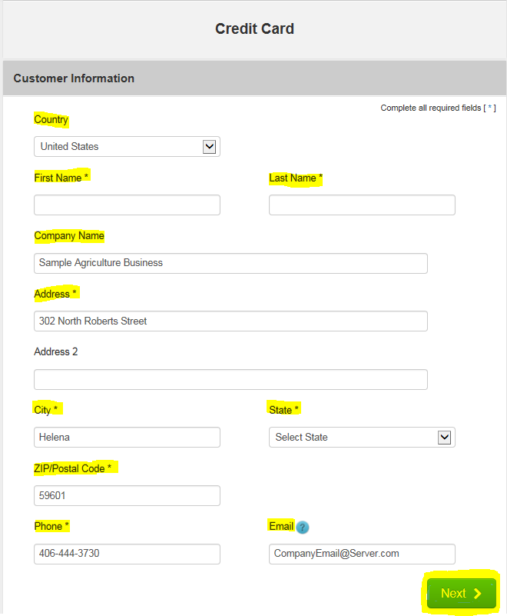

Fill out the Customer Information section including: Country, First and Last Name, Company Name, Address, City, State, ZIP Code, Phone Number, and Email.

Select Next.

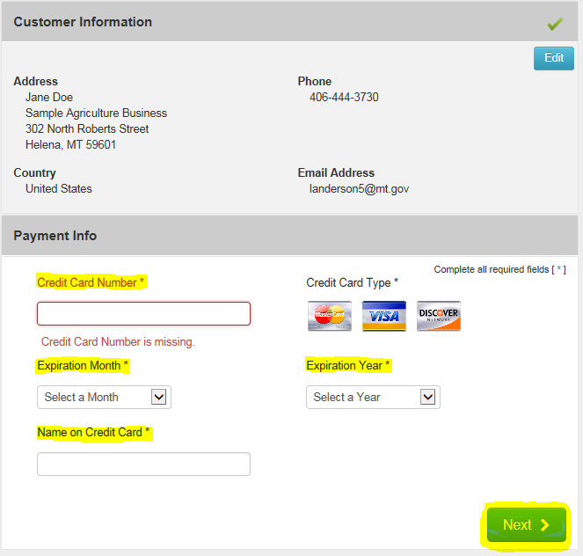

Verify the Customer Information and enter the Payment Information including the Credit Card Number, Expiration Month, Expiration Year, and Name on Credit Card.

Select Next.

Note: The Montana Department of Agriculture does not accept American Express.

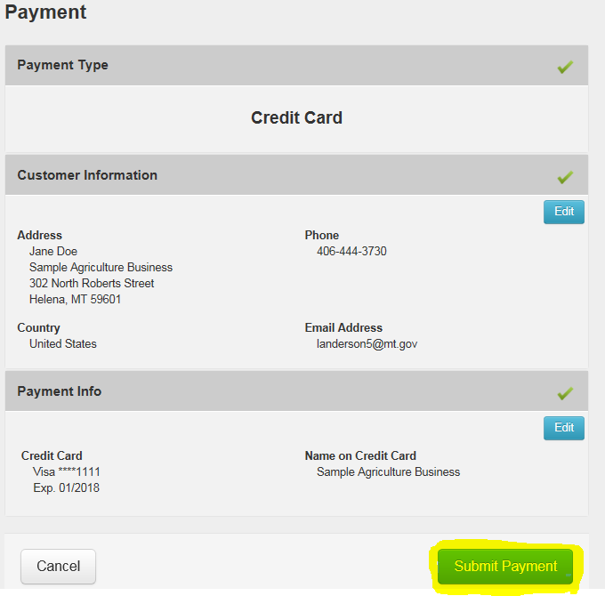

Verify the Customer Information and the Payment Info.

Select Submit Payment.

This will send you to the payment confirmation page and give you an opportunity to print your license. (See Step 9)

**Electronic Check (E-Check)**

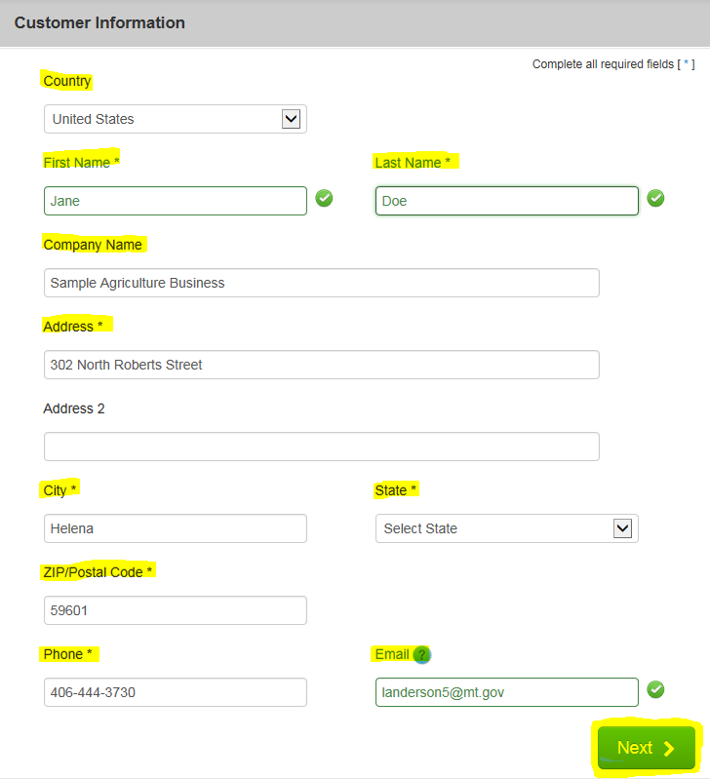

Fill out the Customer Information section including: Country, First and Last Name, Company Name, Address, City, State, ZIP Code, Phone Number, and Email.

Select Next.

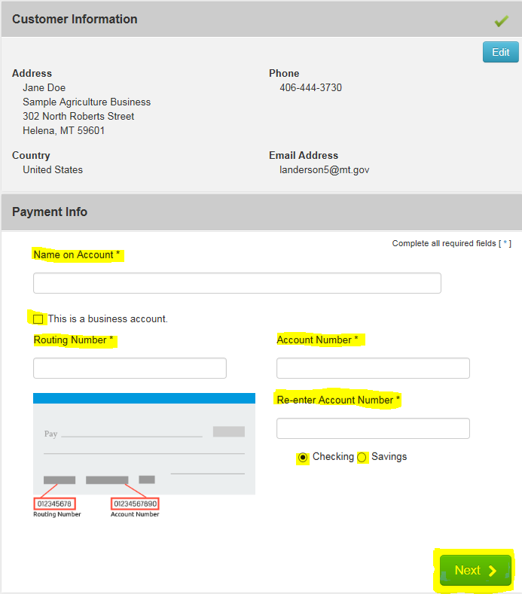

Verify the Customer Information and enter the Payment Information including the Name on the Account, Routing Number, Account Number, Re-enter the Account Number, and select the appropriate account type (checking or savings).

If this is a Business Account, select the “This is a business account” check box.

Select Next.

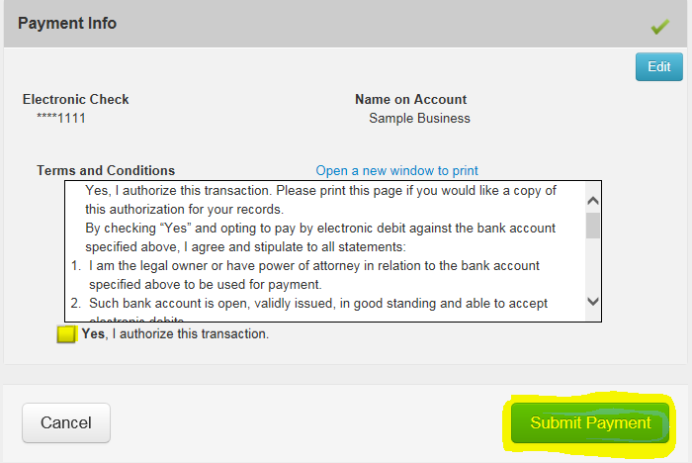

Read through to the bottom of the Terms and Conditions.

Select the check box to authorize the transaction.

Select the Submit Payment button.

This will send you to the payment confirmation page and give you an opportunity to print your license.

**Step 9: Payment Confirmation**

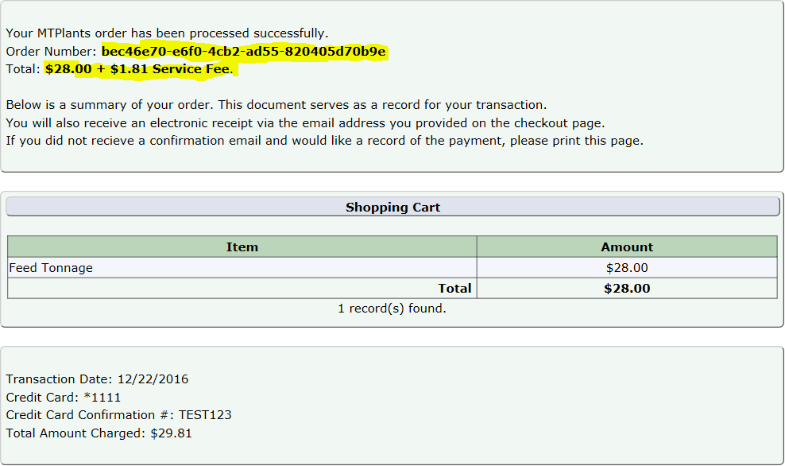

You will be transferred to the payment confirmation page and a confirmation email will be sent to the email address provided during checkout.

On this page you will be able to see the transaction order number and the total of the transaction.

This completes the Fertilizer Quarterly Tonnage Reporting process.