Application Instructions
Enter your User ID and Password to login to WebGrants https://fundingmt.org.
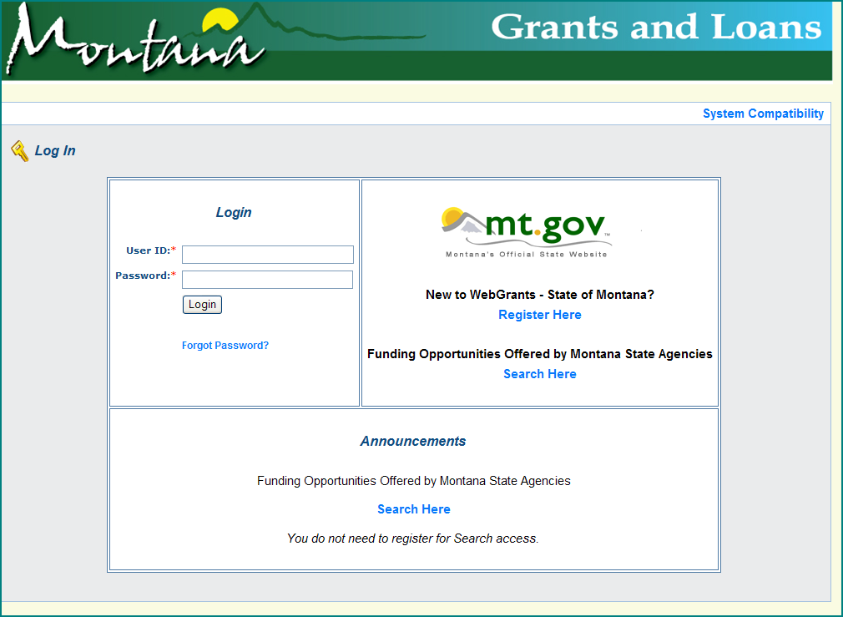
Click on “Funding Opportinuties” to view all State of Montana funding opportunities.
Click on the Specialty Crop Block Grant funing opportunity in the Opportunity Title column.

Click on “Start a New Application” to start the application process.

Enter the name of the project in the “Project Title” text box. Then click on “Save” (at the top right).

Enter project title in this box.

This screen allows you to make changes to the project title by clicking on “Edit” or to continue to the application forms by clicking on “Go to Application Forms”. To select additional contacts, designate an authorized contact or make other edits to this screen, click “Edit” to add those individuals.
Now, you can click on any form and begin filling in the required information for that form.
REMEMBER #1: the column “Complete?” must have a check mark in it for each form before WebGrants will allow the application be submitted.
REMEMBER #2: It is highly recommended that you draft all narrative in a word processing program and copy and paste into these forms. This will also prevent you from losing data while working on the application due to system time outs

