**How to Renew a Seed License**

**Step 1: Log In**

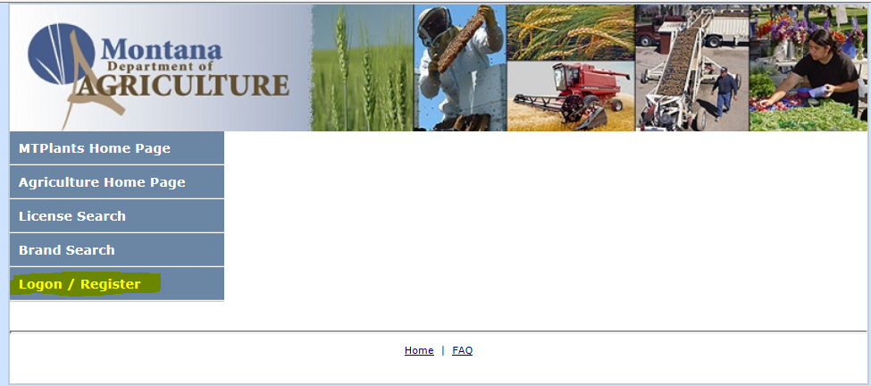

Go to: <https://mtplants.mt.gov>

Select Logon/Register.

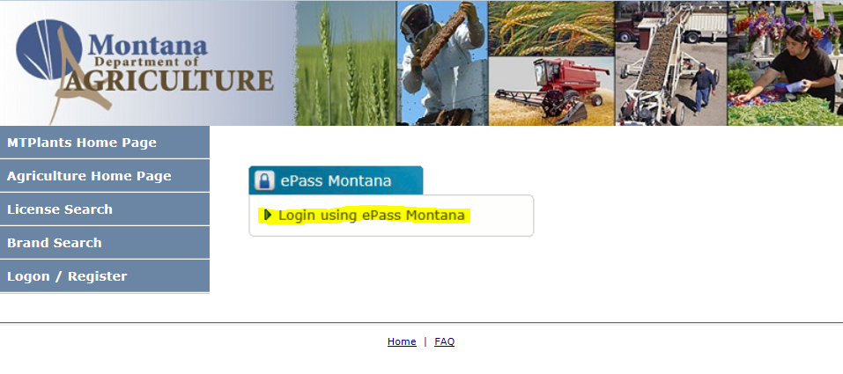

Select Login using ePass Montana.

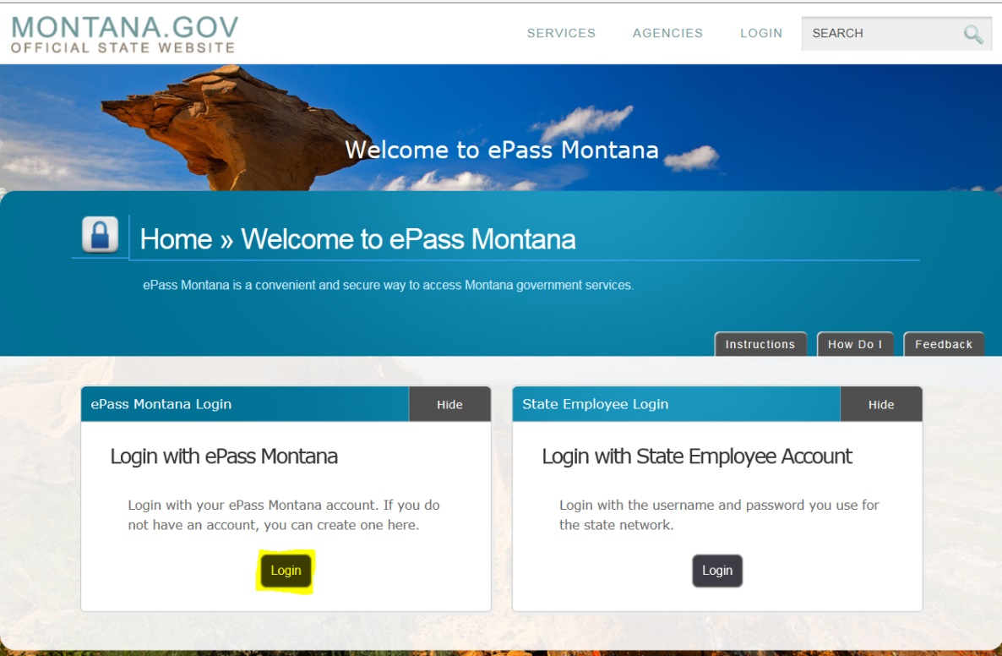

Select the Login button in the Login with ePass Montana box.

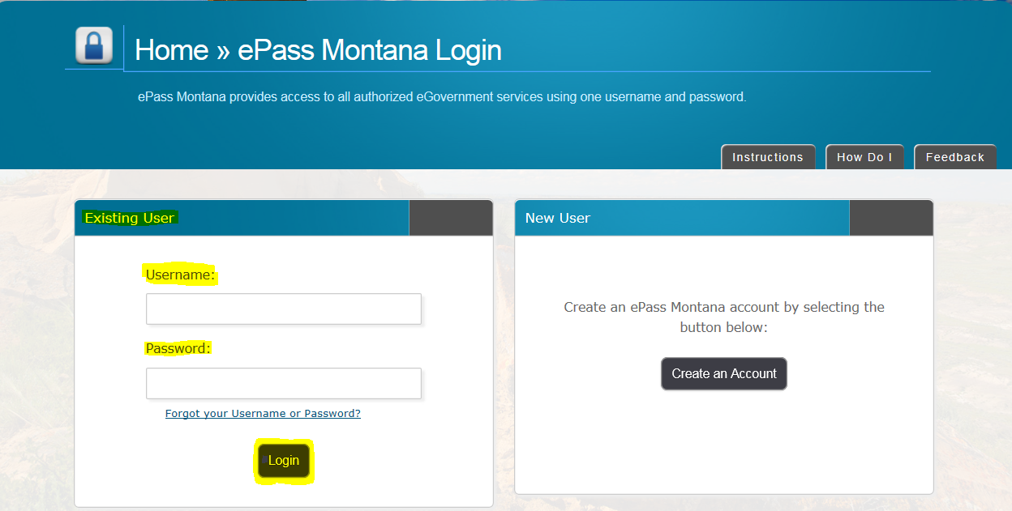

If you already have an ePass account enter your information in the Existing User box and select Login.

If you do not have an account please see: How to Create and ePass Account and Activate Your MTPlants Account.

**Step 2: Add License to Shopping Cart**

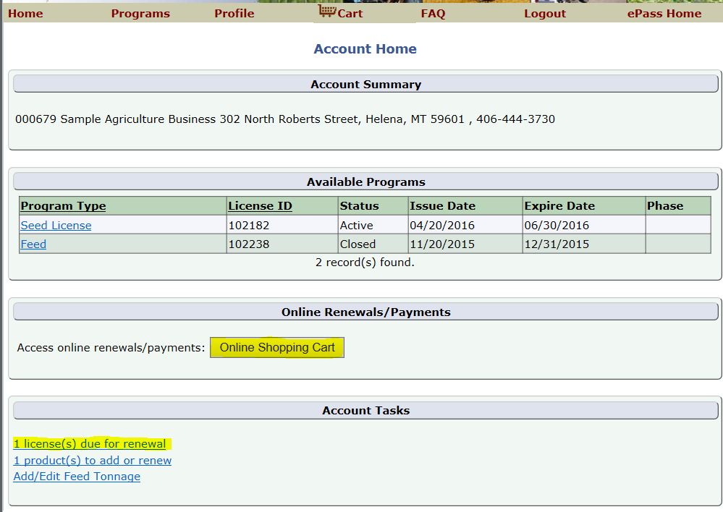

From the Account Summary on the Account Home page select either the Online Shopping Cart button or the License Due for Renewal hyperlink in the Account Tasks.

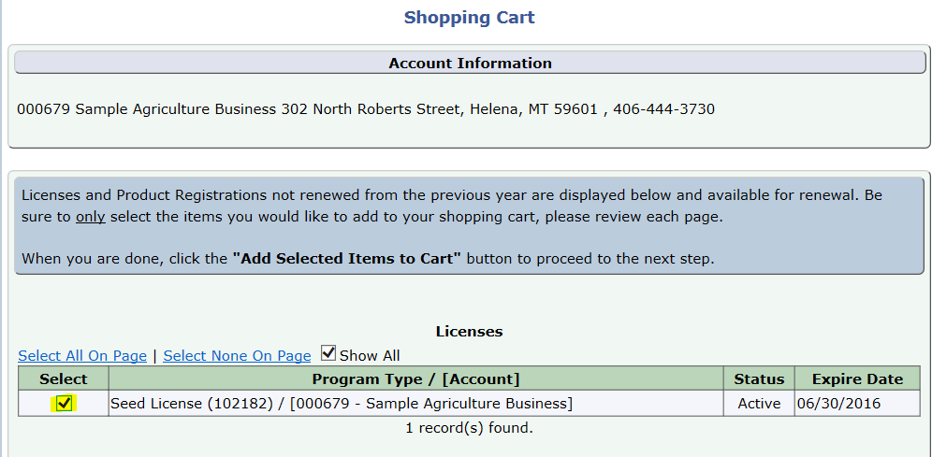

Check the box next to the license you would like to renew.

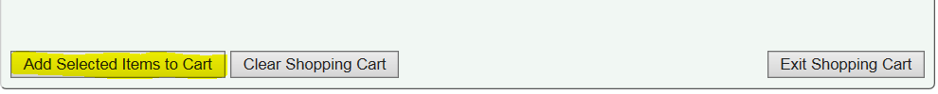

Select Add Selected Items to Cart.

**Step 3: Verify Account Information**

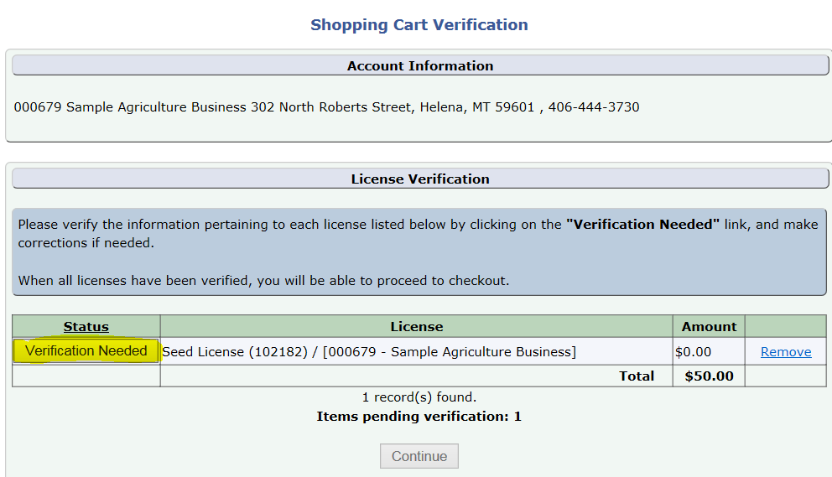

Select the Verification Needed button.

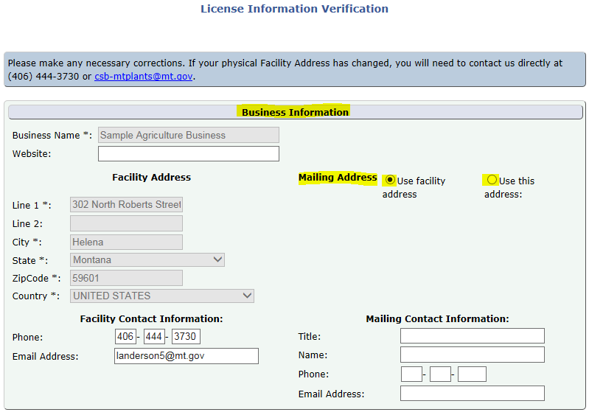

Verify your Business Information.

If you need to change the physical Facility Address, you will need to contact us directly at (406) 444-3730 or [csb-mtplants@mt.gov](mailto:csb-mtplants@mt.gov).

If the Mailing address differs from the Facility Address select the “Use this address” radial and enter the appropriate mailing address.

**Step 4: Verify and update Portable Conditioning Plants (if not applicable skip to Step 5)**

To add a Portable Conditioning Plant select the Add button.

Enter the Plate No, Make, Model, and Year of the trailer the Conditioner is on.

If the trailer is homemade indicate “Homemade” in the Make, distinguishing characteristics in the Model (Vin, length, type, etc.), and indicate the year the trailer was made in the Year.

Select Save & Back.

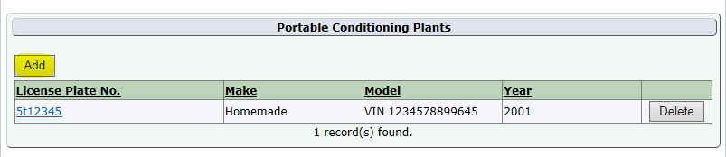

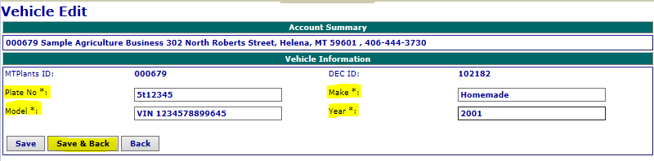

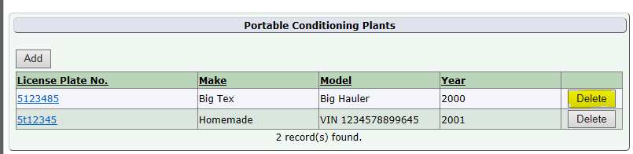

To remove a Portable Conditioning Plant select the Delete button.

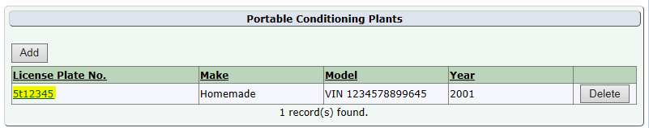

To edit an existing Portable select the hyperlinked license plate number, make any necessary changes, and select save.

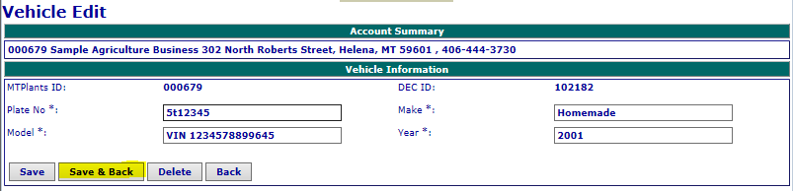

**Step 5: Operation Type Verification**

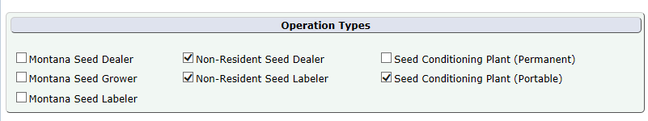

Verify the Operation Type(s) listed for this company and make any necessary changes.

**Step 6: Seed Labelers must attach a sample of their label (if not applicable skip to Step 7)**

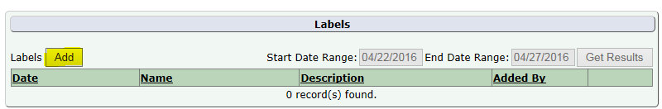

All Seed Labelers are required to attach a sample of their label.

Select the Add button

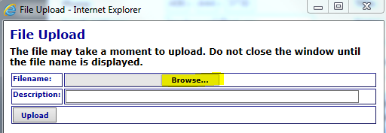

Select Browse to search your computer for the label file.

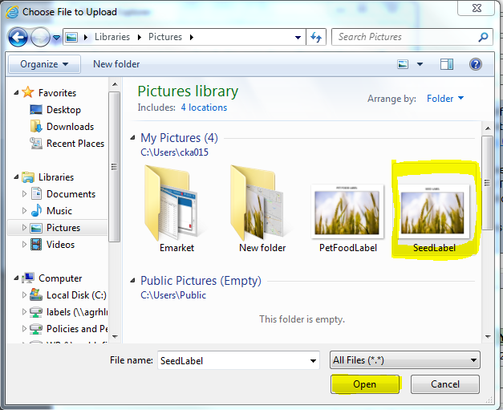

Navigate the location the label is saved, select the label and select Open.

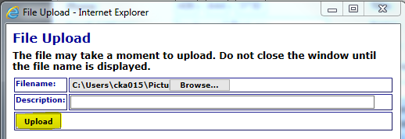

This will populate the label into the Uploader.

Enter a description of the label and select Upload.

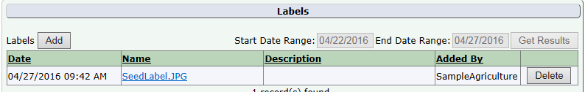

The label appears in the Labels Grid.

**Step 7: Finish Verification**

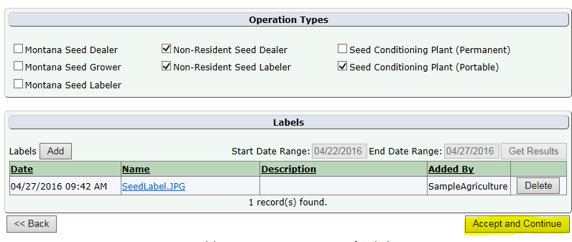

When finished with the applicable steps above select Accept and Continue.

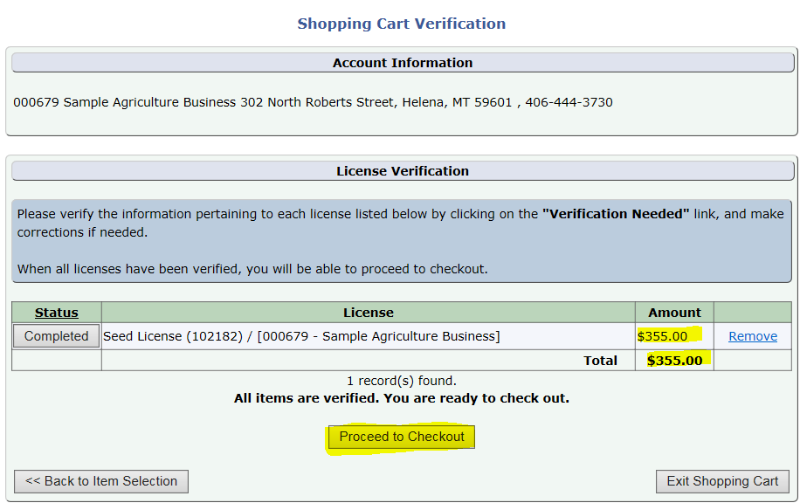

Verify the Total and Select Proceed to Checkout.

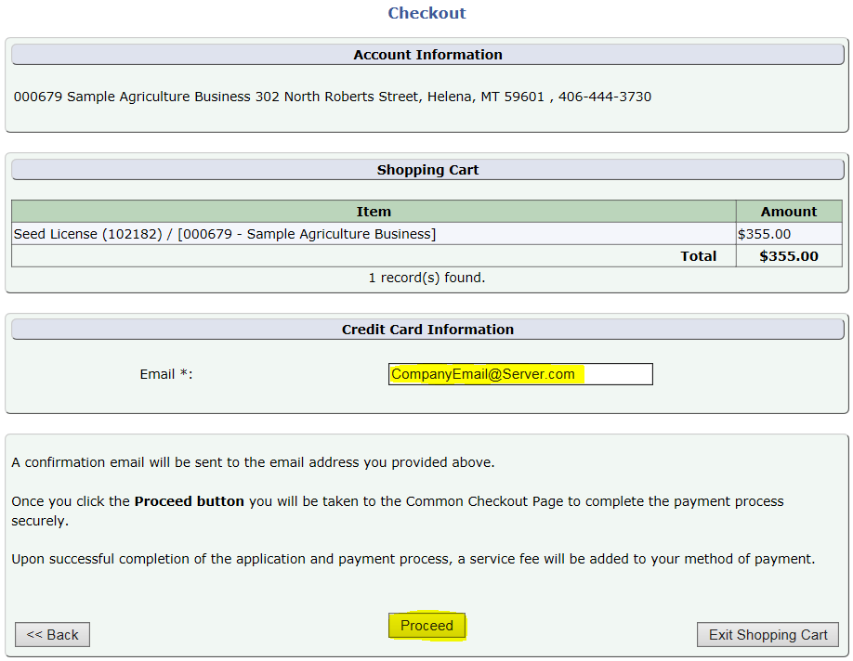

Verify the email address.

This will be the email address that receives the payment confirmation email.

When the information looks correct select Proceed.

**Step 8: Payment Information & Method**

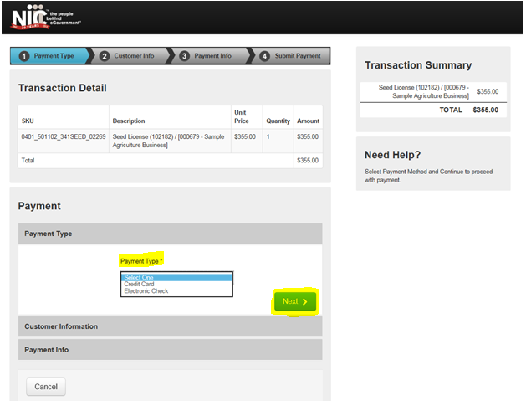

This transfers you over to the NIC payment site.

Select the Payment Type you would like to use from the dropdown.

Select Next.

Note: The processing fees vary based on the payment type: E-Checks are charged a flat $2 fee, and Credit Cards are $1.25 + 1.995% of the transaction amount.

**Credit Card**

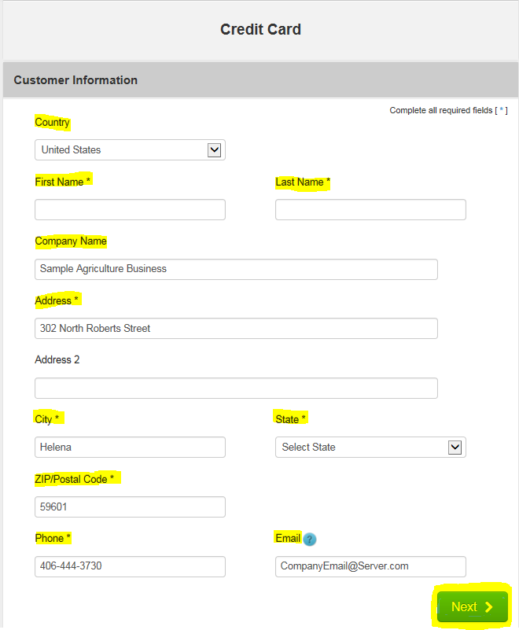

Fill out the Customer Information section including: Country, First and Last Name, Company Name, Address, City, State, ZIP Code, Phone Number, and Email.

Select Next.

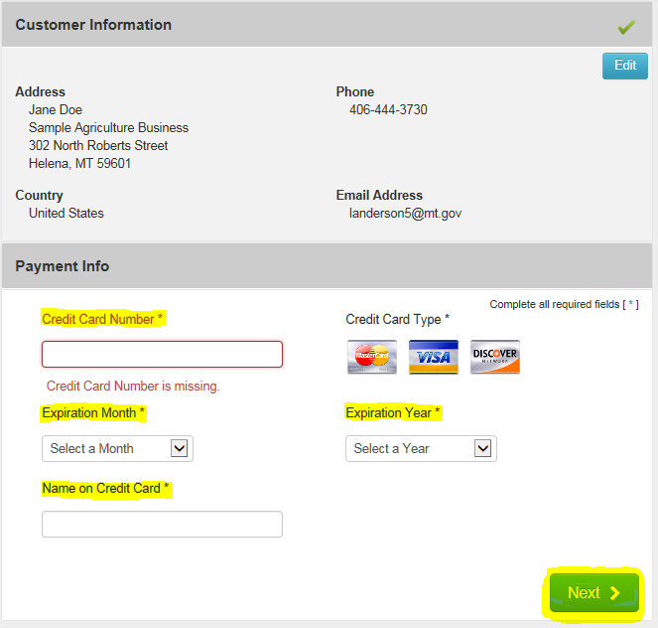

Verify the Customer Information and enter the Payment Information including the Credit Card Number, Expiration Month, Expiration Year, and Name on Credit Card.

Select Next.

Note: The Montana Department of Agriculture does not accept American Express.

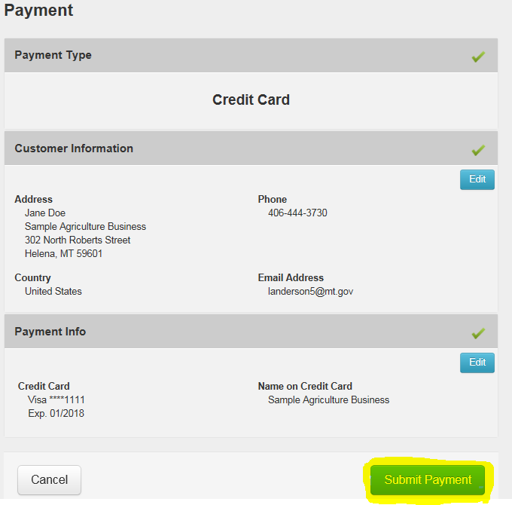

Verify the Customer Information and the Payment Info.

Select Submit Payment.

This will send you to the payment confirmation page and give you an opportunity to print your license. (See Step 9)

**Electronic Check (E-Check)**

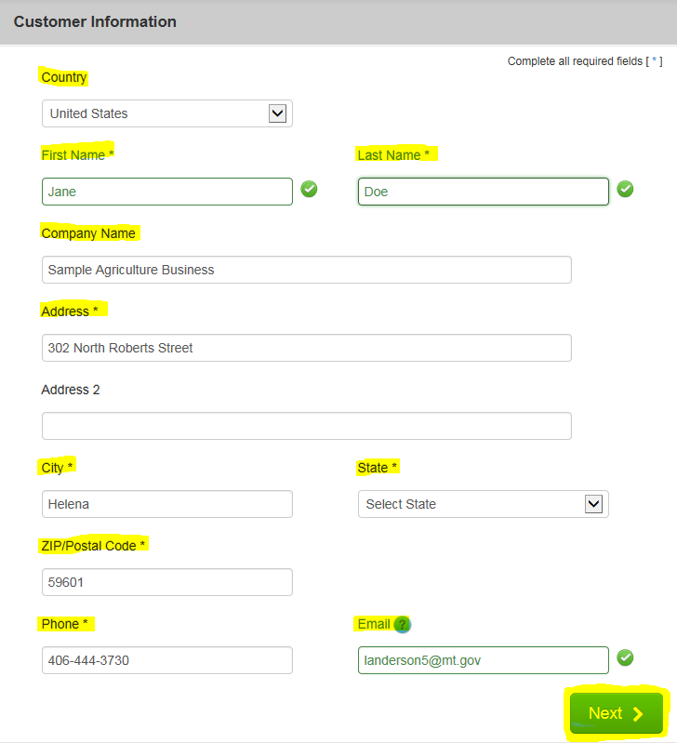

Fill out the Customer Information section including: Country, First and Last Name, Company Name, Address, City, State, ZIP Code, Phone Number, and Email.

Select Next.

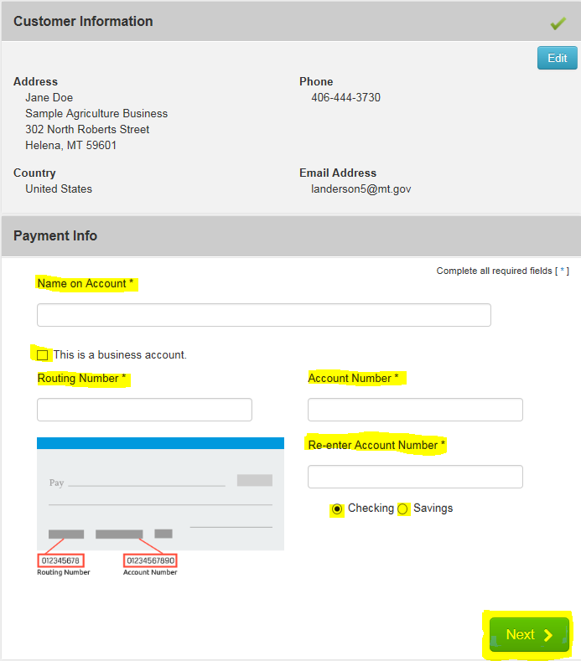

Verify the Customer Information and enter the Payment Information including the Name on the Account, Routing Number, Account Number, Re-enter the Account Number, and select the appropriate account type (checking or savings).

If this is a Business Account, select the “This is a business account” check box.

Select Next.

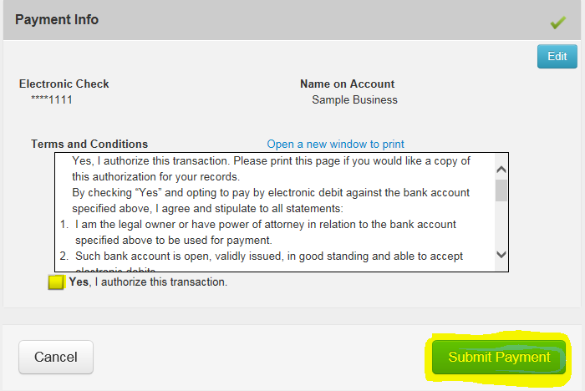

Read through to the bottom of the Terms and Conditions.

Select the check box to authorize the transaction.

Select the Submit Payment button.

This will send you to the payment confirmation page and give you an opportunity to print your license.

**Step 9: Payment Confirmation & Print License**

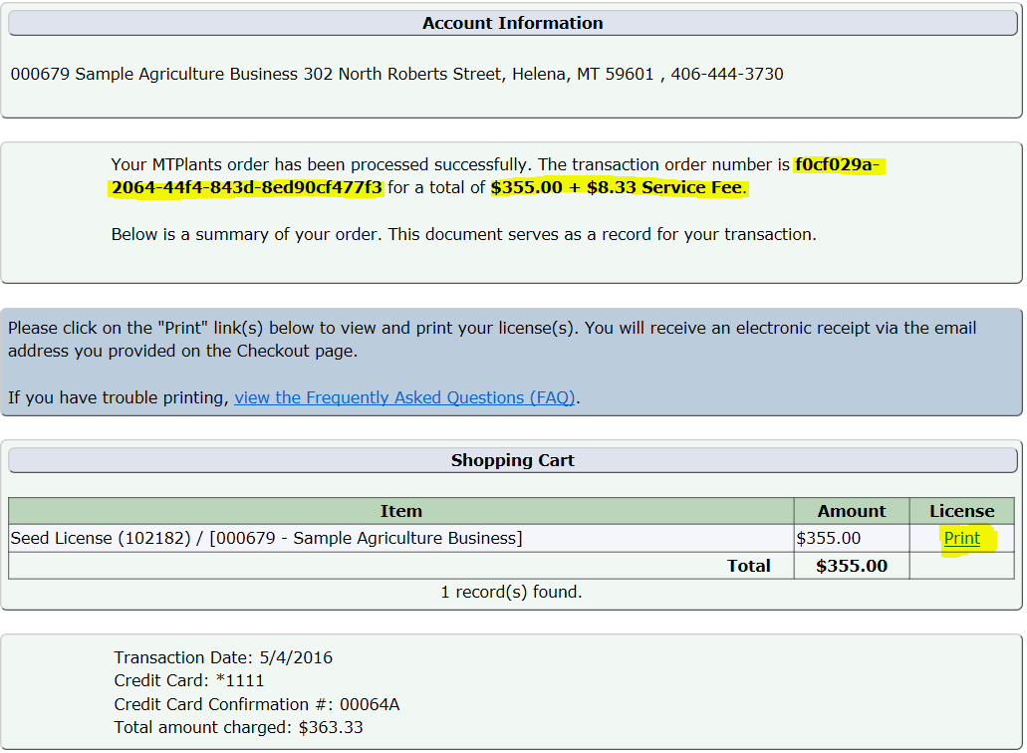

You will be transferred to the payment confirmation page and a confirmation email will be sent to the email address provided during checkout.

On this page you will be able to see the transaction order number and the total of the transaction.

Now that the payment has been processed you will need to print your new license by selecting the Print hyper link.

This completes the license renewal process.