**How to Add New Fertilizer Products Online with MTPlants**

The new database system MTPlants allows users to add and pay for new products at any time throughout the year. The new products and their corresponding labels are automatically sent to the Fertilizer Specialist for review and approval. You will be notified immediately upon approval and will be able to print an updated Brands Certificate that will contain all of your current brands.

**Step 1: Log In**

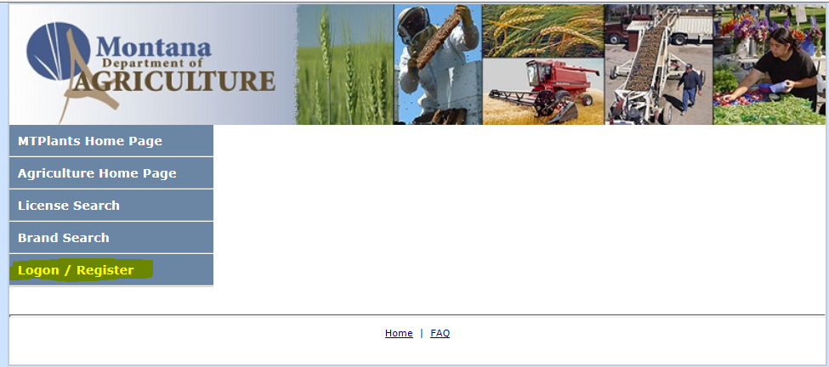

Go to: <https://mtplants.mt.gov>

Select Logon/Register.

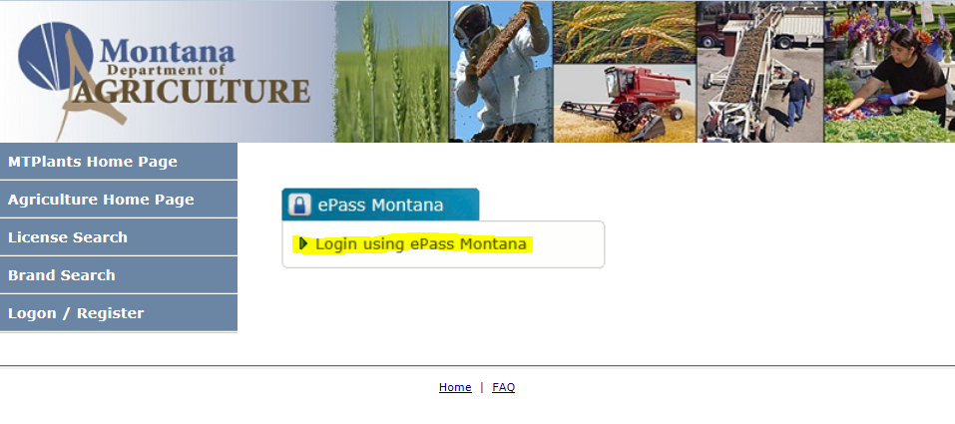

Select Login using ePass Montana.

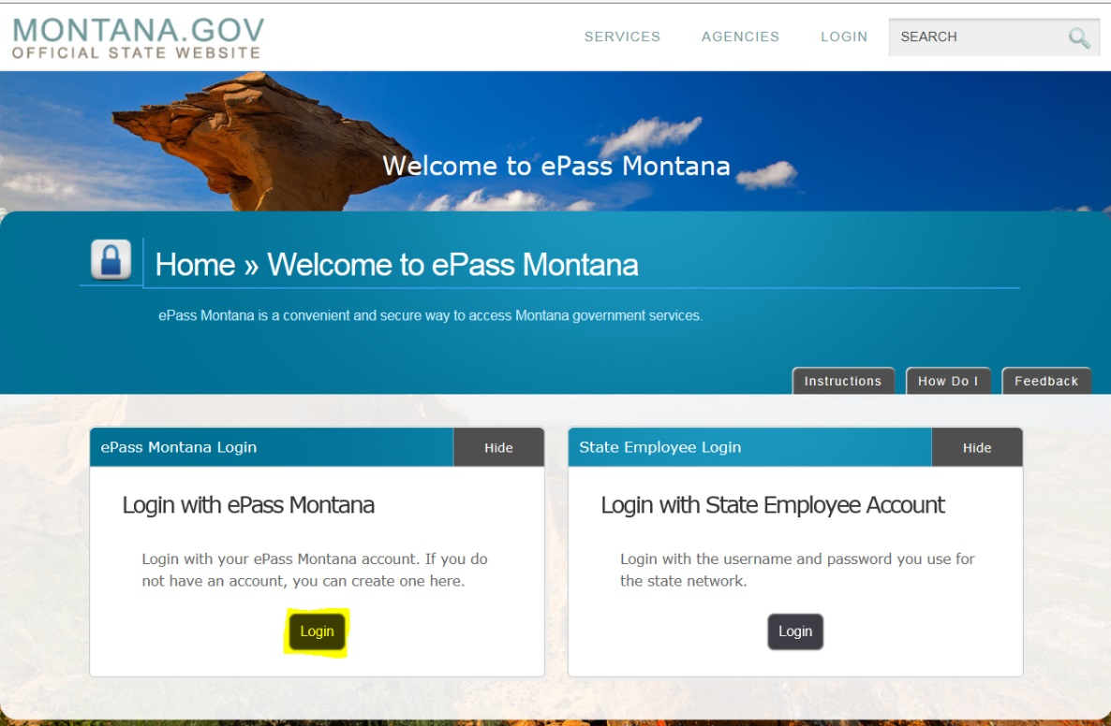

Select the Login button in the Login with ePass Montana box.

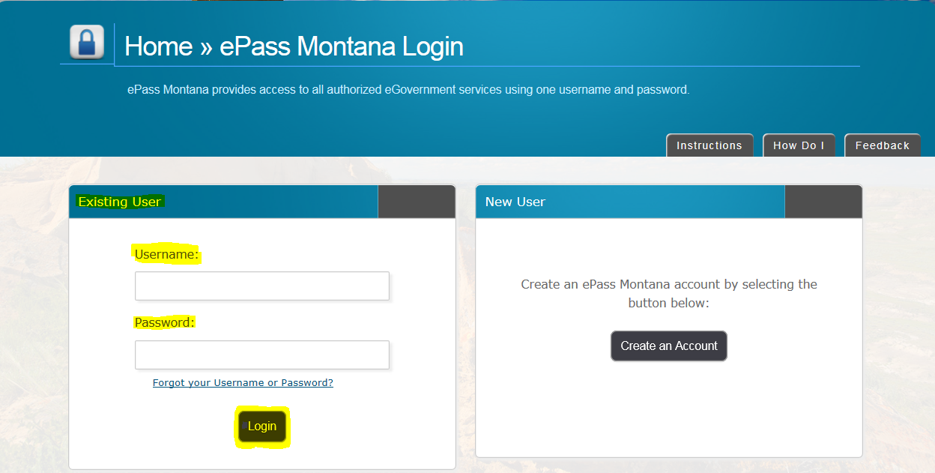

If you already have an ePass account enter your information in the Existing User box and select Login.

If you do not have an account please see: How to Create and ePass Account and Activate Your MTPlants Account.

**Step 2: Add New Product and Labels**

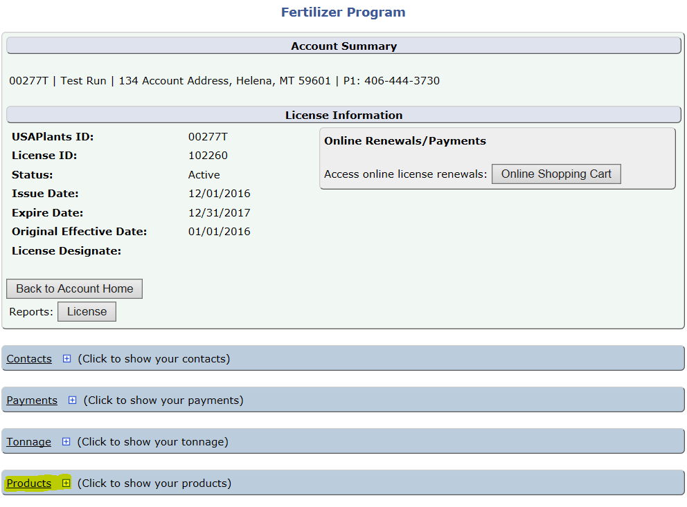

If your company has multiple program licenses this brings you to the Account Home page. Select the hyperlink for the program you want to add products for.

If you have a single program license this brings you to the Program Home page.

Scroll down and expand the Products grid.

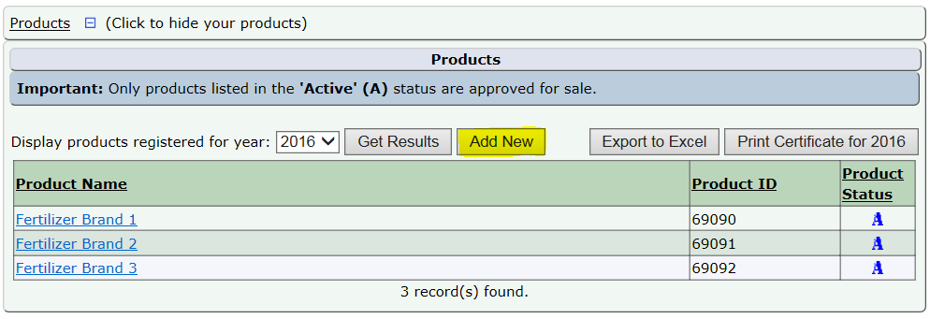

This displays all the products for your company.

Select the Add New button.

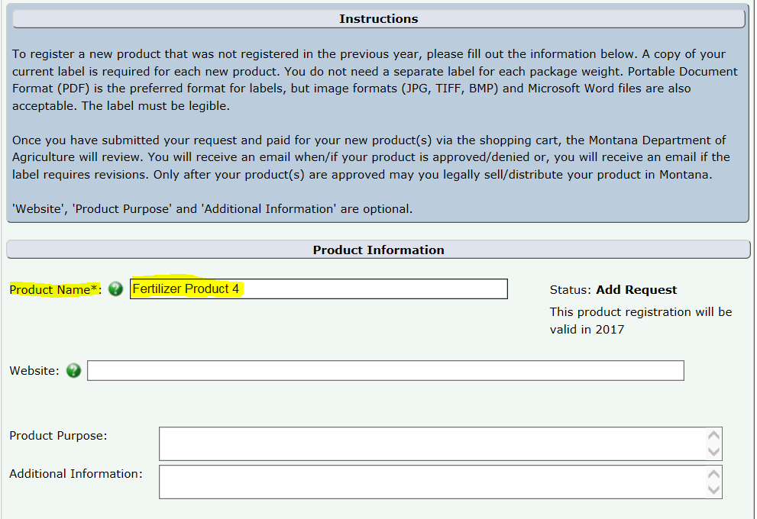

Enter the name of the Product exactly as it appears on the label.

If you would like, you can enter a product description.

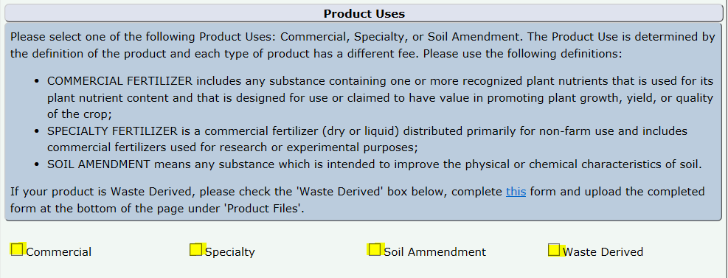

Using the definitions and instructions provided, Select the appropriate Product use.

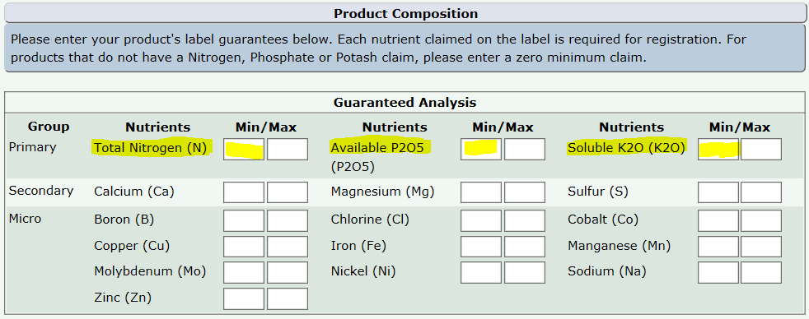

Enter your product’s guarantees as it appears on the label.

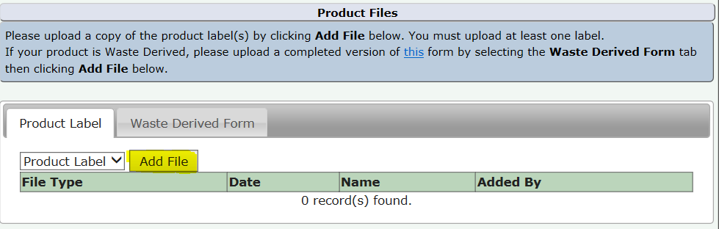

On the Product Label tab, Select the Add File button to upload the products label.

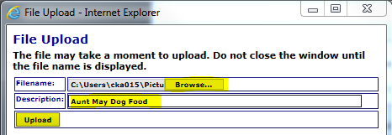

This File Uploader will appear (your pop-up blocker must be off for this to function).

Enter a description of the label, this is typically the product name followed by the year.

Select Upload.

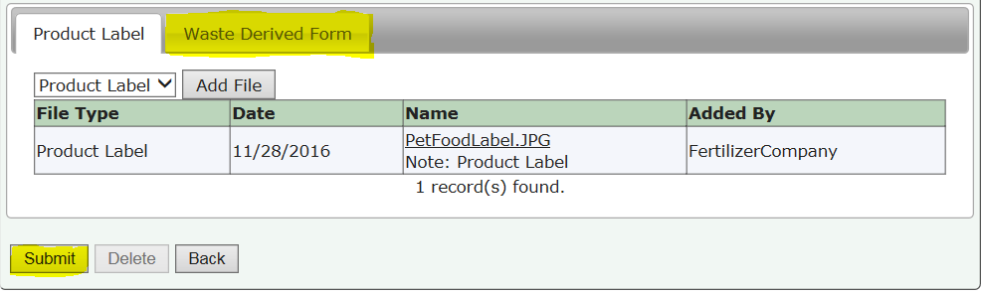

The label will appear under the Product Files grid.

If your product is also Waste Derived you will also need to upload the Waste Derived form.

Select Submit.

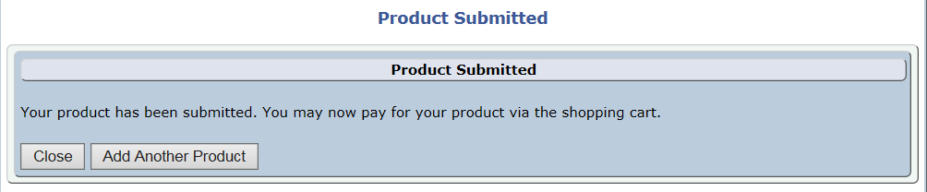

If you need to add another product Select Add Another Product.

If you are finished adding new products, Select Close. You will be returned to the Program Home Page.

Repeat the process beginning with selecting the Add button in the Products grid.

**Step 3: Add New Product to Shopping Cart**

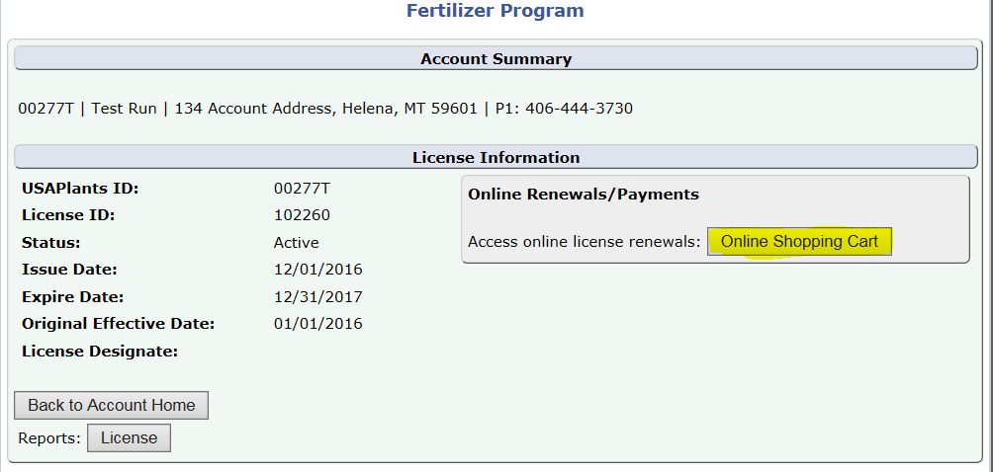

When you are finished adding new products and are returned to the Program page, Select the Online Shopping Cart button.

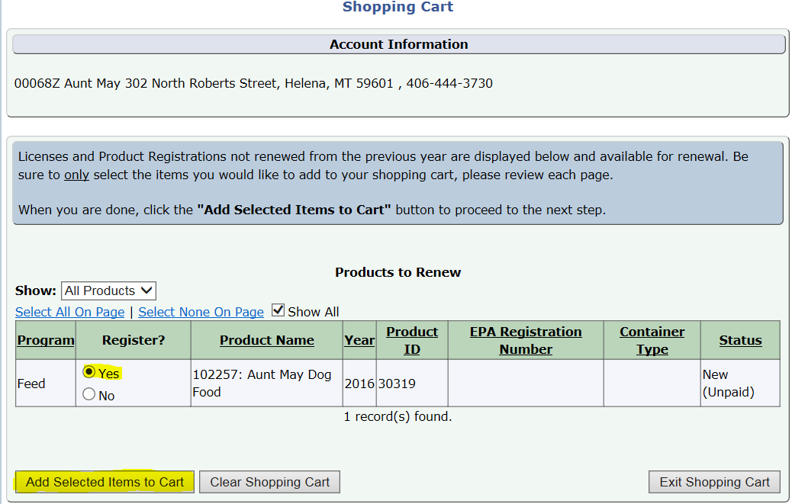

This will bring you to the Shopping Cart.

Select the Yes radial for all the products you wish to register.

Then select Add Selected Items to Cart

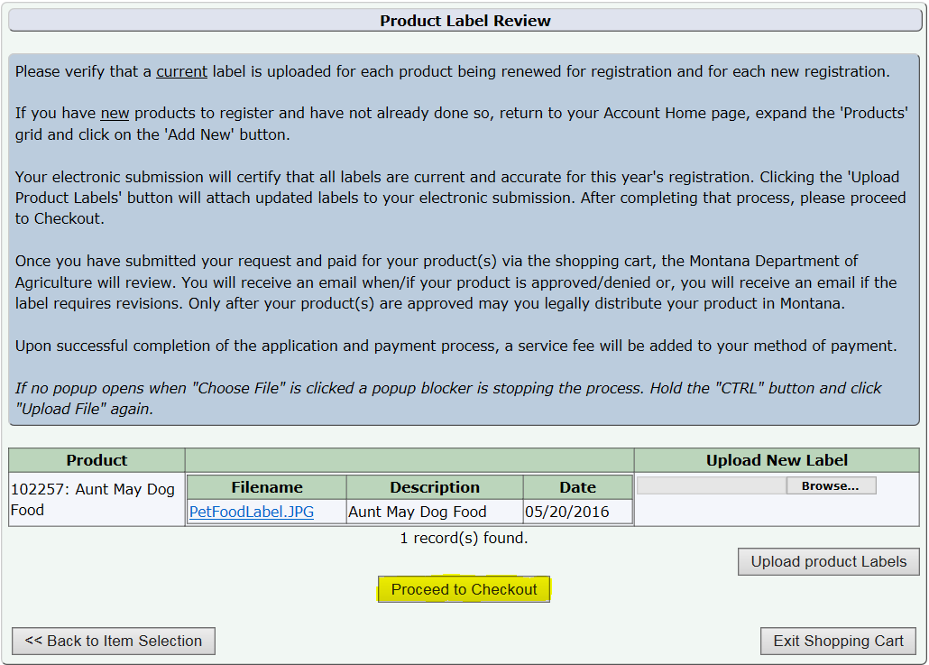

If all the labels appear correct select Proceed to Checkout.

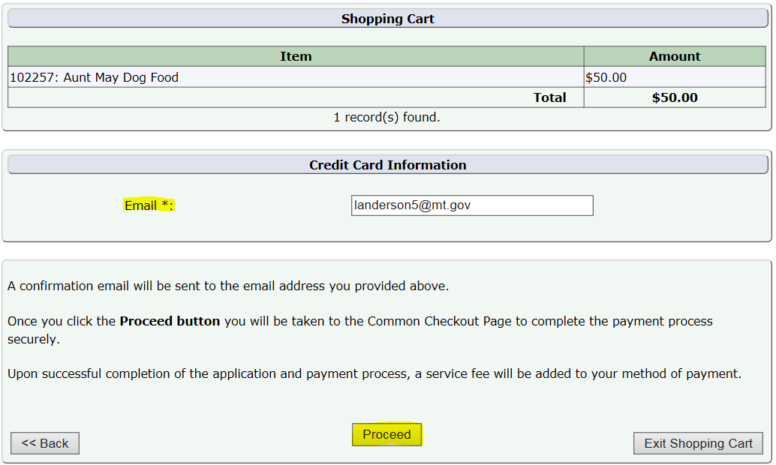

Verify the amount and email address (this will be the email that receives the receipt and product approval/denial emails).

Select Proceed.

**Step 4: Payment Information & Method**

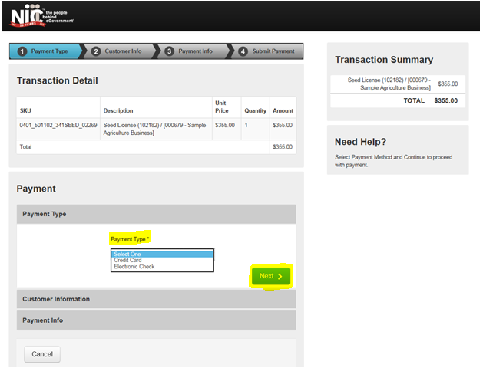

This transfers you over to the NIC payment site.

Select the Payment Type you would like to use from the dropdown.

Select Next.

Note: The processing fees vary based on the payment type: E-Checks are charged a flat $2 fee, and Credit Cards are $1.25 + 1.995% of the transaction amount.

**Credit Card**

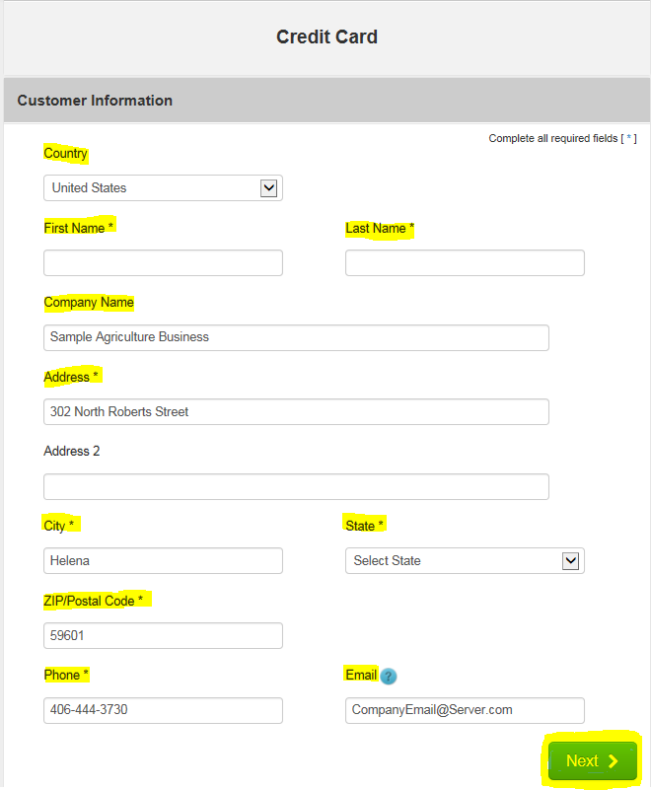

Fill out the Customer Information section including: Country, First and Last Name, Company Name, Address, City, State, ZIP Code, Phone Number, and Email.

Select Next.

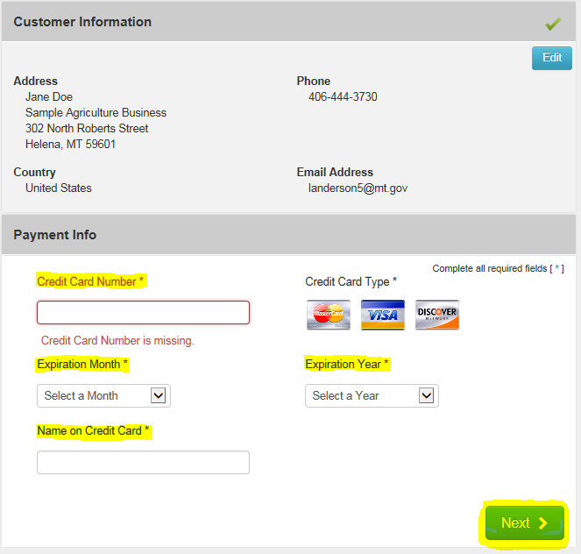

Verify the Customer Information and enter the Payment Information including the Credit Card Number, Expiration Month, Expiration Year, and Name on Credit Card.

Select Next.

Note: The Montana Department of Agriculture does not accept American Express.

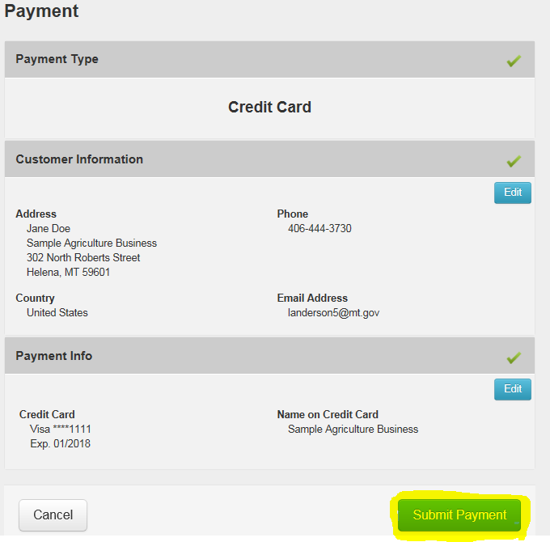

Verify the Customer Information and the Payment Info.

Select Submit Payment.

This will send you to the payment confirmation page and give you an opportunity to print your license. (See Step 9)

**Electronic Check (E-Check)**

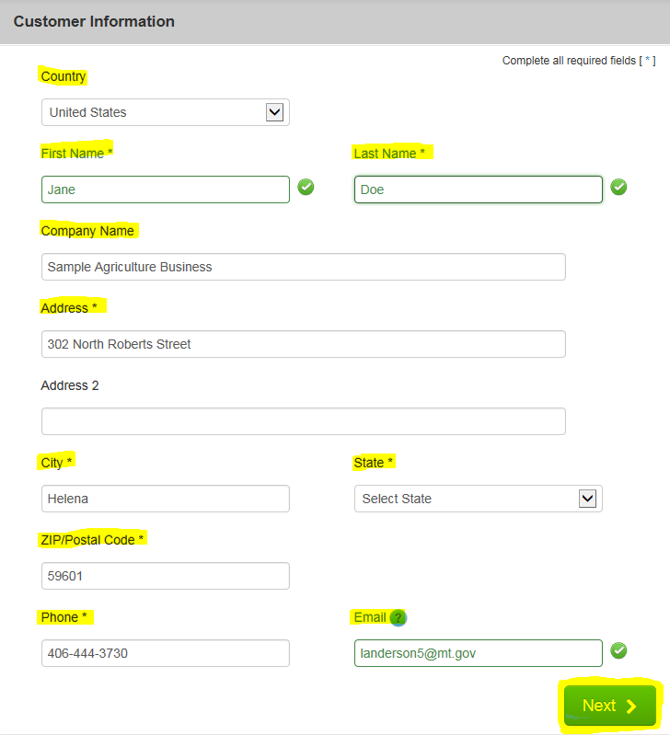

Fill out the Customer Information section including: Country, First and Last Name, Company Name, Address, City, State, ZIP Code, Phone Number, and Email.

Select Next.

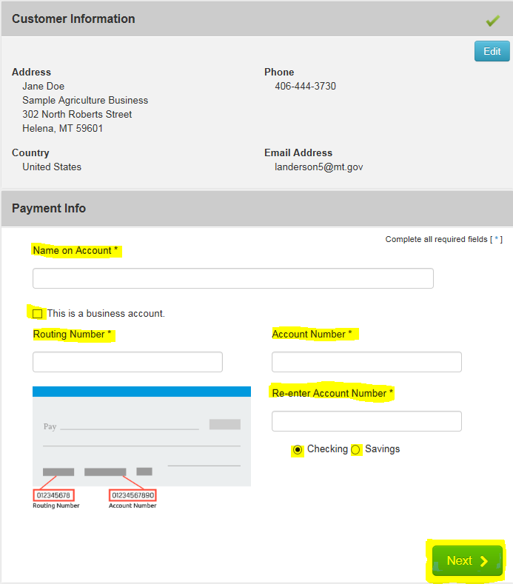

Verify the Customer Information and enter the Payment Information including the Name on the Account, Routing Number, Account Number, Re-enter the Account Number, and select the appropriate account type (checking or savings).

If this is a Business Account, select the “This is a business account” check box.

Select Next.

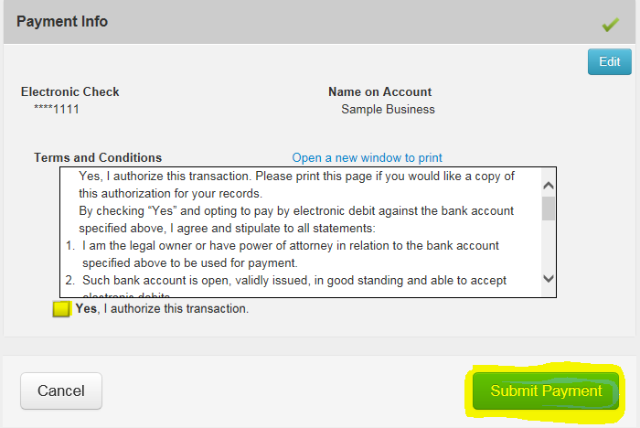

Read through to the bottom of the Terms and Conditions.

Select the check box to authorize the transaction.

Select the Submit Payment button.

This will send you to the payment confirmation page and give you an opportunity to print your license.

**Step 5: Payment Confirmation**

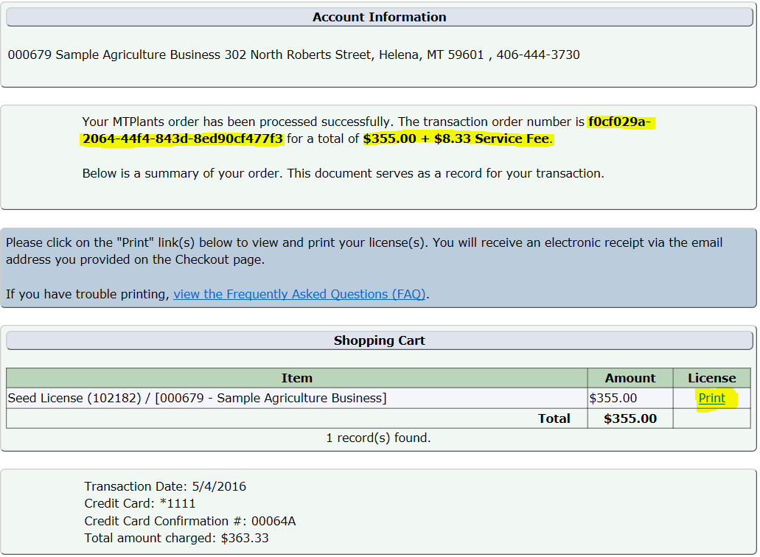

You will be transferred to the payment confirmation page and a confirmation email will be sent to the email address provided during checkout.

On this page you will be able to see the transaction order number and the total of the transaction.

**Step 6: Print an Updated Product Certificate**

The Montana Department of Agriculture will review your product label and contact you via email if your product is approved, denied, or if there are further questions.

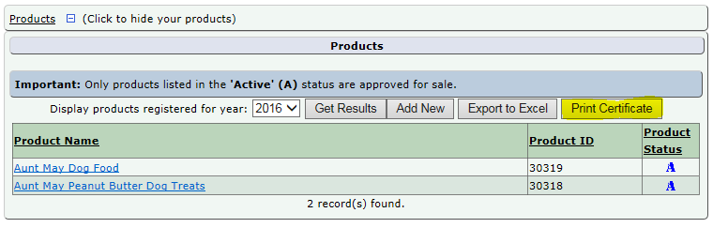

If the product is approved you will then be able to log into your MTPlants account and print an updated product certificate.