**How to Add Fertilizer Semi-Annual Tonnage**

**Step 1: Log In**

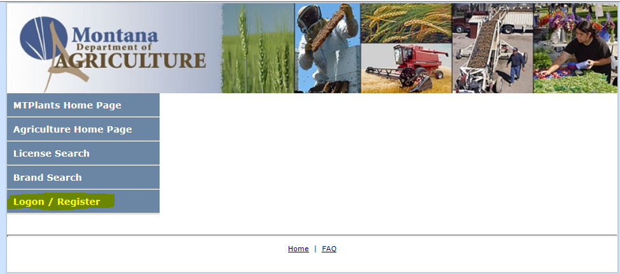

Go to: <https://mtplants.mt.gov>

Select Logon/Register.

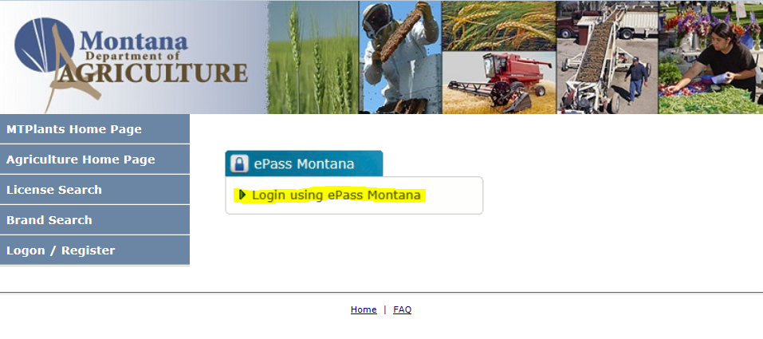

Select Login using ePass Montana.

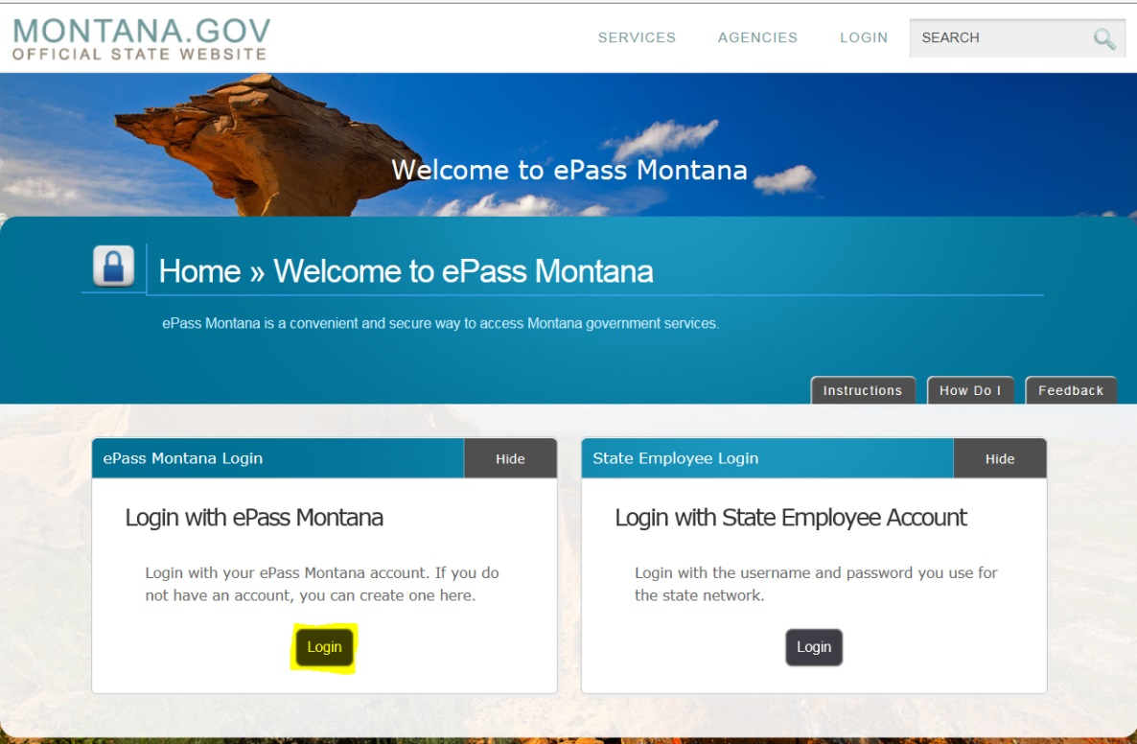

Select the Login button in the Login with ePass Montana box.

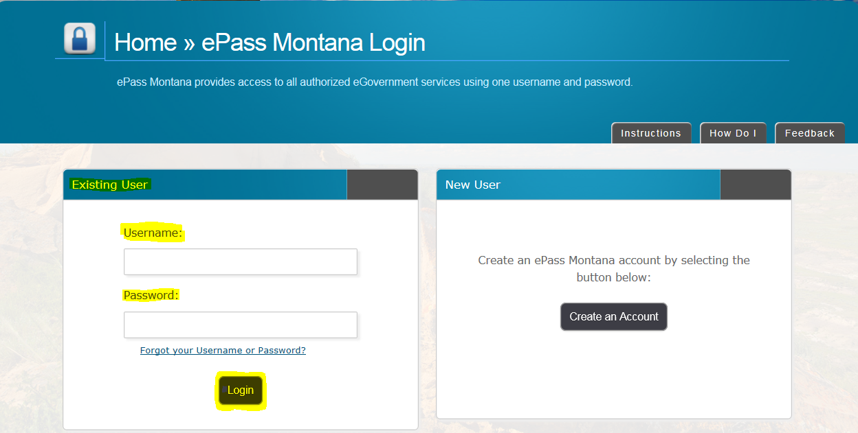

If you already have an ePass account enter your information in the Existing User box and select Login.

If you do not have an account please see: How to Create and ePass Account and Activate Your MTPlants Account.

**Step 2: Entering Tonnage Information**

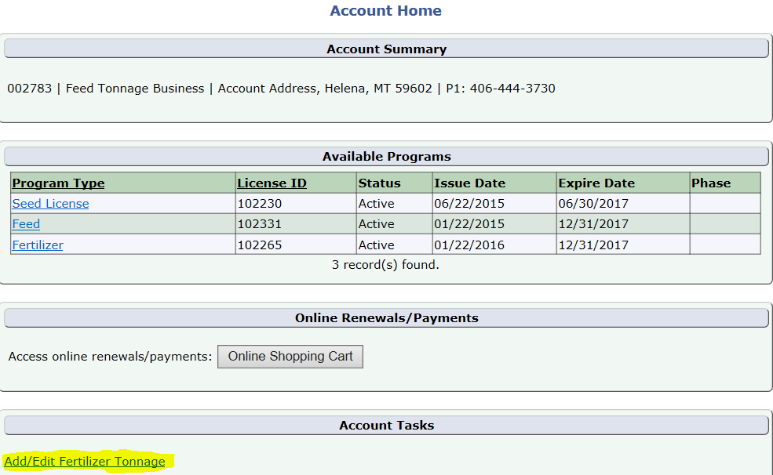

From the Account Summary on the Account Home page select the Add/Edit Fertilizer Tonnage hyperlink in the Account Tasks.

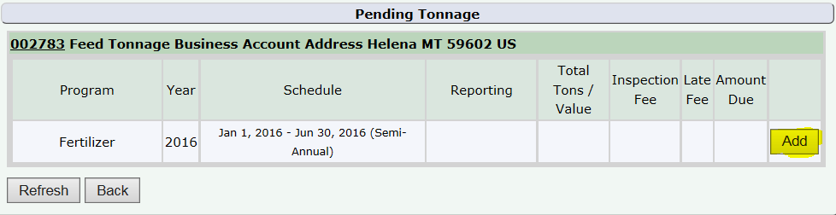

This brings up the Tonnage Grid. Select the Add button next to the tonnage you would like to enter.

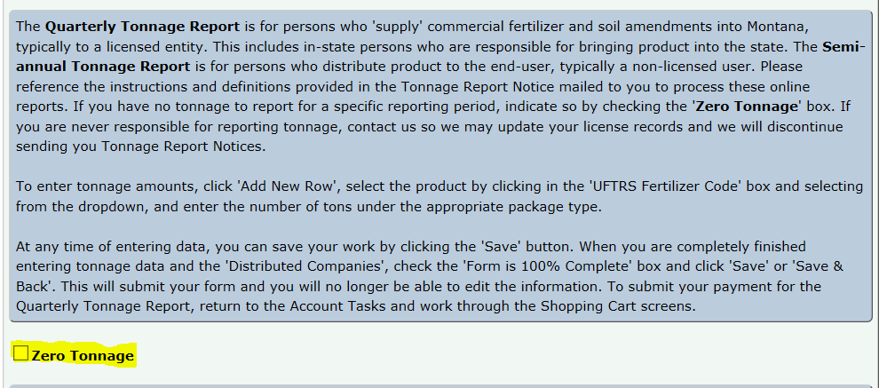

The Tonnage Edit screen will then appear. If you have no tonnage to report for the period indicated Select the Zero Tonnage box.

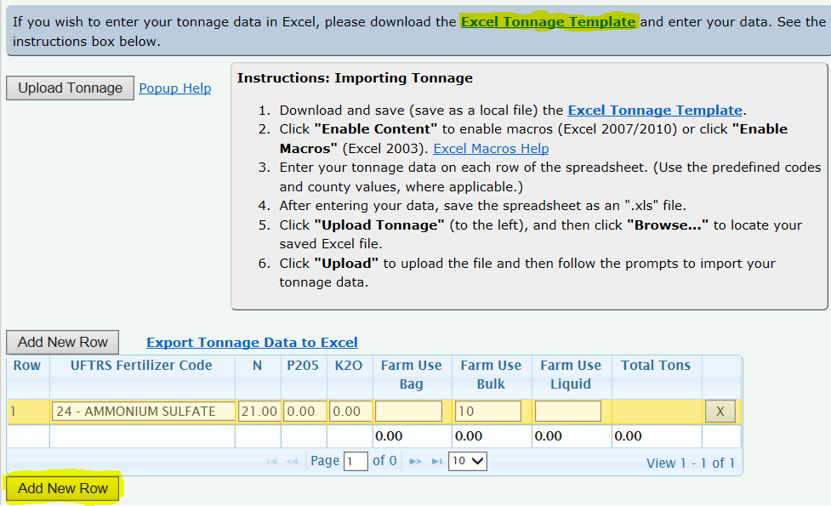

There are two ways to add tonnage. You can follow the instructions to import your tonnage information using a downloaded spread sheet. Or you can manually add the data by selecting Add New Row, Selecting the tonnage type from the drop down and entering in the amount.

When all of your tonnage has been entered Select the Save button.

If the Totals appear correct, Select the Form is 100% Complete box and Select Save & Back

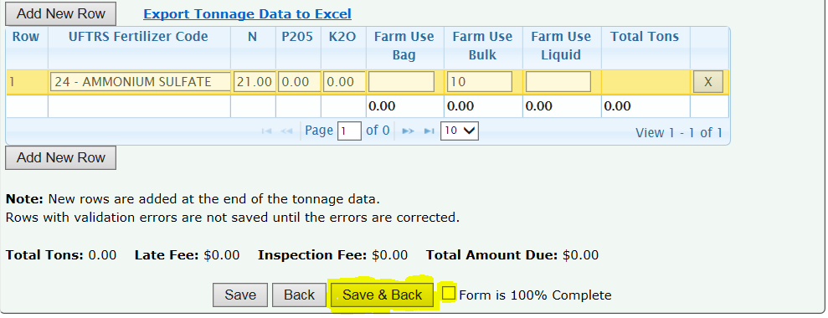

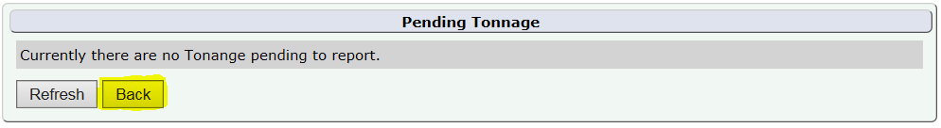

If you have no other tonnage due to report Select the Back button.

Since there are no fees associated with the Semi-Annual Tonnage Report this completes the reporting process.